

# Digital Accessibility Centre

# Accessibility audit report for Studio 24

# 

|  |  |
| --- | --- |
| Company | Studio 24 |
| Date | 10th June |
| DAC Ref. | 000749 |
| Version | Final |
| Standard | WCAG 2.1 |



© 2021 Digital Accessibility Centre Limited, All Rights Reserved

**Disclosure**

Pursuant to item 7 in our terms and conditions, this report and its findings are intended for the client organization. Any other use of this material that is attributed to Digital Accessibility Centre, including delivery of excerpts, paraphrases, or edited versions to anyone not employed by the client organization must be approved by us in writing.

## Document Control

|  |  |
| --- | --- |
| Service: | <https://w3c-dev.studio24.dev/forms.html> |
| Client: | Studio 24 |
| Project lead: | Tom Nasmyth-Shaw |
| User testing support | James Bradley |
| Technical auditor | Tom Nasmyth-Shaw & Deborah Roberts |
| Quality checked by: | Deborah Roberts/ Georgina Williams |
| Address: | Digital Accessibility Centre  Stephen Lloyd Suite (Unit 18)  Darcy Business Park  Llandarcy  Neath  SA10 6FG |
| Contact details: | [Gavin.evans@digitalaccessibilitycentre.org](mailto:Gavin.evans@digitalaccessibilitycentre.org)  079366 85804  [Cam.nicholl@digitalaccessibilitycentre.org](mailto:Cam.nicholl@digitalaccessibilitycentre.org)  07597 690358  [Tom.shaw@digitalaccessibilitycentre.org](mailto:Tom.shaw@digitalaccessibilitycentre.org)  07745544181 |
| Phone: | 01792 815267 |
| Date of audit: | 25th May 2021 |
| Date report issued: | 10th June 2021 |

## Contents

Digital Accessibility Centre 1

Accessibility audit report for Studio 24 1

Document Control 2

Contents 3

Executive Summary 5

Audit Summary 6

Scope 7

Tasks 7

Browser matrix and Assistive Technology (AT) combinations 8

Summary Graphs 9

Analyst Feedback 9

WCAG 2.1 Breakdown 10

Audit Results 11

*** High priority *** 12

Unlabelled input 12

Issue ID: DAC-Unlabelled-input 12

Non-descriptive links 14

Issue ID: DAC-Non-descriptive-links- 14

Non-descriptive errors/ links 16

Issue ID: DAC-Non-descriptive-errors/links 16

Incorrect use of ARIA 18

Issue ID: DAC-Incorrect-use-of-ARIA 18

Autocomplete 19

Issue ID: DAC-Autocomplete 19

*** Medium priority *** 21

Resize text/ Reflow 21

Issue ID: DAC-Resize-text 21

Duplicated buttons 24

Issue ID: DAC-Duplicated-buttons 24

Non-descriptive heading 26

Issue ID: DAC-Non-descriptive-heading 26

*** Low priority *** 28

Ambiguous links 28

Issue ID: DAC-Ambiguous-link 28

*** Usability *** 30

Labels 30

Issue ID: DAC-Labels 30

Fieldset & legend 33

Issue ID: DAC-Fieldset-&-legend 33

Calendar 1 36

Issue ID: DAC-Calendar-issue1 36

Calendar 2 38

Issue ID: DAC-Calendar-issue2 38

Details component 1 40

Issue ID: DAC-Details-component-issue1 40

Details component 2 43

Issue ID: DAC-Details-component-issue2 43

Numerical limit 47

Issue ID: DAC-Numerical-limit 47

Problematic input 1 48

Issue ID: DAC-Problematic-input-issue1 48

Problematic input 2 52

Issue ID: DAC-Problematic-input-issue2 52

Skip links 54

Issue ID: DAC-Skip-links 54

Nested lists 56

Issue ID: DAC-Nested-lists 56

Images 59

Issue ID: DAC-Images 59

Carousel 60

Issue ID: DAC-Carousel 60

Styling 62

Issue ID: DAC-Styling 62

Link 63

Issue ID: DAC-Link 63

End of Report 64

Appendix I 65

Appendix II 66

Classification of Accessibility Issues 66

The Process 87

CRITERIA 88

DAC Testing Procedure 89

## Executive Summary

An accessibility audit for **Studio 24** was carried out by the Digital Accessibility Centre (DAC) user/ technical team in **May/ June 2021.**

The service was assessed against the Web Content [Accessibility Guidelines WCAG 2.1](https://www.w3.org/TR/WCAG21/).

This document incorporates the findings regarding any accessibility barriers identified during the testing process.

Our analysts did not encounter major issues when testing the pages in the scope, and apart from the minor issues for example, relating to the details component, no accessibility barriers were encountered by our Dragon analyst or keyboard only analysts.

Our screen reader analyst found that generally tasks were easy to complete, with only minor issues which made it more time consuming to use some components where issues occurred; however, some high WCAG fails were identified relating to an unlabelled input, problematic autocomplete and non-descriptive links and error messages.

Many of the components behaved differently with different software and browser combinations, meaning that some screen reader users may find a component more difficult to use.

The date of arrival feature was problematic to use with multiple methods of navigation and may in some extreme cases prevent users from accessing the component or surrounding areas on the page.

The area to add a new comment was also confusing, as an indication was provided to enter a reply.

Usability feedback has been provided towards the end of the report, that although do not fail to meet WCAG 2.1, may cause issues for some users; fixing these issues would provide an even better experience for screen reader users.

## Audit Summary

In order for the service to be eligible for a Digital Accessibility Centre certification, and fall in line with WCAG 2.1 requirements, improvements need to be made in the following areas.

 A

Unlabelled input

Non-descriptive links  
Non-descriptive errors/link

Incorrect use of ARIA

Autocomplete

Carousel

 AA

Resize text/Reflow  
Duplicated buttons

Non-descriptive heading

 AAA

Ambiguous links

## Scope

### Tasks

Brief Task and/ or URLs are listed below along with the specific browser and AT set.

URL: <https://w3c-dev.studio24.dev/forms.html>

See Appendix I for a full list of tasks and instructions.

### Browser matrix and Assistive Technology (AT) combinations

**Desktop**

|  |  |  |  |
| --- | --- | --- | --- |
| **User type** | **Operating System (OS)** | **Browser** | **Assistive Technology** |
| Blind | Windows | IE11 | JAWS 18 and 2019 |
| Firefox | NVDA |
| Mobility | Windows | IE11 | Dragon Voice Activation v15 |
| Mobility | Windows | Chrome | Keyboard |
| IE11 | Keyboard |
| Colour blind/ Dyslexia | Windows | Chrome | - |
| Low Vision | Windows | Chrome | Screen Magnification,  Reflow *, Text Spacing † |
| IE11 | System inverted colours |
| Cognitive Impaired | Windows | Chrome | - |

**\* Reflow** tests withscreen size of 1280 x 1024px, at 400% browser magnification

† **Text Spacing** tests with larger Line height, and larger Paragraph, Word and Letter spacing.

**Mobile/ Tablet**

|  |  |  |  |  |
| --- | --- | --- | --- | --- |
| **User type** | **Code** | **Operating System (OS)** | **Browser** | **Assistive Technology** |
| Blind | SR | iOS/Android | Safari/Chrome | VoiceOver /TalkBack |
| Mobility | KO | iOS | Safari | - |
| Colour blind/ Dyslexia | CB/DX | iOS | Safari | Colour blind checks |
| Low Vision | LV | iOS | Safari | Resizing content |

## Summary Graphs

### Analyst Feedback

Our analysts provided their overall feedback on the service.

This was rated from 0 – could not complete to 3 – Completed independently, no issues.

|  |  |
| --- | --- |
| **Key:** |  |
| 0 | Could not complete on my own |
| 1 | Completed independently but with major issues |
| 2 | Completed independently but with minor issues |
| 3 | Completed independently, no issues |

### WCAG 2.1 Breakdown

The graphs below detail the number of checkpoints that passed, failed or were not applicable to the service.

Please refer to the Classification of Accessibility Issues for more information.

|  |  |  |
| --- | --- | --- |
| **A** | | |
| **Priority Level** | **Number** | **Percentage: High Priority Results** |
| Number of checkpoints ‘Passed’ | 13 (43%) |  |
| Number of checkpoints ‘Failed’ | 3 (10%) |
| Number of checkpoints ‘Not Applicable (N/A)’ | 14 (47%) |

|  |  |  |
| --- | --- | --- |
| **AA** | | |
| **Priority Level** | **Number** | **Percentage: Medium Priority Results** |
| Number of checkpoints ‘Passed’ | 8 (40%) |  |
| Number of checkpoints ‘Failed’ | 4 (20%) |
| Number of checkpoints ‘Not Applicable (N/A)’ | 8 (40%) |

|  |  |  |
| --- | --- | --- |
| **AAA** | | |
| **Priority Level** | **Number** | **Percentage: Low Priority Results** |
| Number of checkpoints ‘Passed’ | 4 (14%) |  |
| Number of checkpoints ‘Failed’ | 1 (3%) |
| Number of checkpoints ‘Not Applicable (N/A)’ | 25 (83%) |

## Audit Results

These are the results of the Digital Accessibility Centre accessibility audit by section.

Each area contains a reference to the WCAG success criteria, a brief overview of the issue encountered, a description of issues found along with user testing commentaries and solutions.

### *** High priority ***

### Unlabelled input

The search input was unlabelled.

**WCAG Reference(s):**

1.3.1 Info and Relationships (Level A)

[Understanding Info and Relationships](https://www.w3.org/WAI/WCAG21/Understanding/info-and-relationships.html) | [How to Meet Info and Relationships](https://www.w3.org/WAI/WCAG21/quickref/#info-and-relationships)

4.1.2 Name, Role, Value (Level A)

[Understanding Name, Role, Value](https://www.w3.org/WAI/WCAG21/Understanding/name-role-value.html) | [How to Meet Name, Role, Value](https://www.w3.org/WAI/WCAG21/quickref/#name-role-value)

#### Issue ID: DAC-Unlabelled-input

URL: <https://w3c-dev.studio24.dev/posts/index.html>

Screenshot:

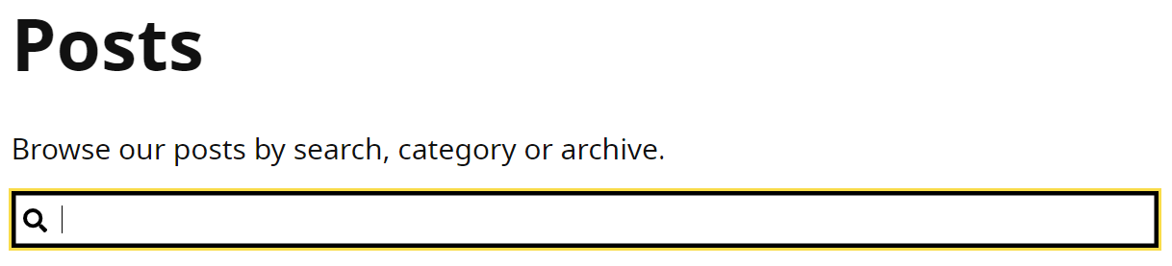

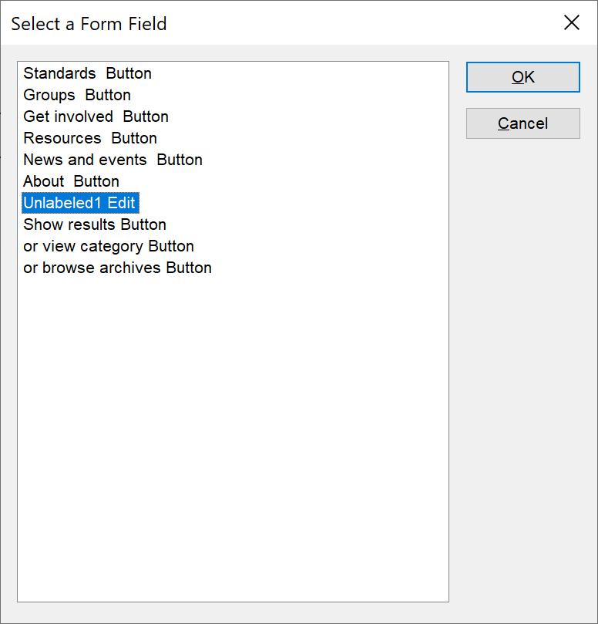

The search input fields is unlabelled; there is no programmatically determined label, although visually there is a paragraph of text that acts as a visible label for sighted users.

Screen reader users will find the input problematic as there is no clear indication what this relates to, both in and out of context.

Voice activation users using Dragon will be unable to speak the name of the label. This helps the user to directly move focus to the input by saying “Click search” for example.

**Current code ref(s)**:

<div class="not-sidebar">

<input type="search" id="search" name="search">

</div>

**Screen reader comments:**

“The field to enter a search term was unlabelled. This made it more problematic especially when browsing out of context to understand what should be entered into the input field. Providing a clear and unique label that is specific to the purpose of the page will enable me to easily input content both in and out of context.

**The issue is consistent with JAWS using Google Chrome and Microsoft Edge Chromium, NVDA and VoiceOver. Please note with TalkBack the software attempts to generate content meaning I am able to understand the purpose of the field.”**

**Solution:**We recommend removing the <p> tag and implementing this as the label. The label will require the ‘for’ attribute which matches the ID of the corresponding input control.

**Example:**

<div class="l-center">

<h1>Posts</h1>

**<label** **for="search"** class="lead">Browse our posts by search, category or archive.**</label>**

<div class="l-sidebar search">

<form role="search" onsubmit="return false" novalidate="">

<div class="not-sidebar">

<input type="search" **id="search"** name="search">

### Non-descriptive links

There were duplicated links that will take users to different destinations.

**WCAG Reference(s):**

2.4.4 Link Purpose – in context (Level A)

[Understanding Link Purpose (In Context)](https://www.w3.org/WAI/WCAG21/Understanding/link-purpose-in-context.html) | [How to Meet Link Purpose (In Context)](https://www.w3.org/WAI/WCAG21/quickref/#link-purpose-in-context)

2.4.9 Link Purpose - Link Only - (Level AAA)

[Understanding Link Purpose (Link Only)](https://www.w3.org/WAI/WCAG21/Understanding/link-purpose-link-only.html) | [How to Meet Link Purpose (Link Only)](https://www.w3.org/WAI/WCAG21/quickref/#link-purpose-link-only)

#### Issue ID: DAC-Non-descriptive-links-

URL: <https://w3c-dev.studio24.dev/posts/index.html>

Screenshot:

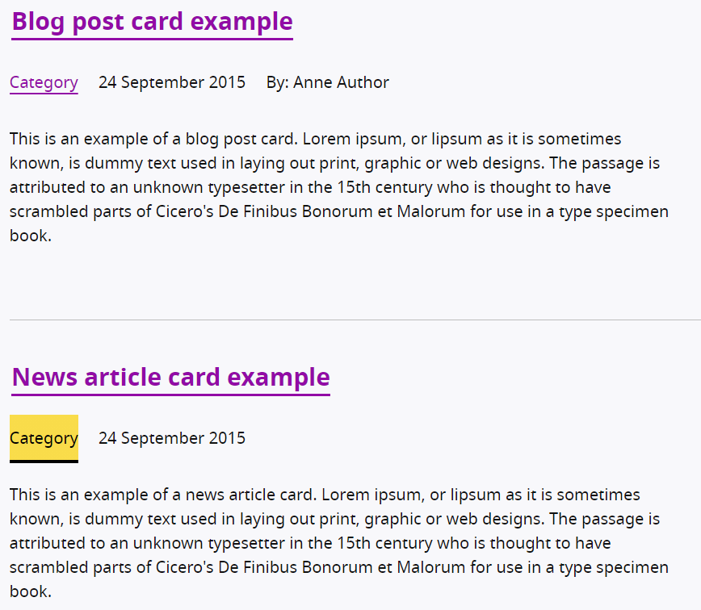

The links entitled ‘Category’ were duplicated; however, it is not known whether these links will take users to different destinations. If they do, this will be confusing for screen reader users at it unclear where the link will take them.

**Current code ref(s)**:

<a href="../page.html">Category</a>

**Screen reader comment:**

“I located multiple links on the page which read to me as ‘Category’ and were duplicated both in and out of context. In a testing environment due to the beta nature of the service I was not able to establish whether the links would lead to the same or a different destination. If the links lead to a different destination I would not have been aware of this out of context and may have become confused. Providing each link with a unique link text would enable me to easily understand where I am being taken, although if the links relate to the same feature indicated by the heading link then the ‘Category’ link mark-up could be removed to remove the duplication. **The issue is present with JAWS using Google Chrome and Microsoft Edge Chromium, NVDA, VoiceOver and TalkBack.**”

**Issue consistent for the following pages:**

Events

Journey 1 step 4

<https://w3c-dev.studio24.dev/listing-events/index.html>

**Solution:**

Provide the user with unique and descriptive hypertext, this could include the type of category i.e. ‘News category’ but this would have to take the user to the same destination as a generic ‘News page’ that contains all news articles.

### Non-descriptive errors/ links

The error links/ messages were not descriptive.

**WCAG Reference(s):**

2.4.4 Link Purpose – in context (Level A)

[Understanding Link Purpose (In Context)](https://www.w3.org/WAI/WCAG21/Understanding/link-purpose-in-context.html) | [How to Meet Link Purpose (In Context)](https://www.w3.org/WAI/WCAG21/quickref/#link-purpose-in-context)

2.4.6 Headings and Labels (Level AA)

[Understanding Headings and Labels](https://www.w3.org/WAI/WCAG21/Understanding/headings-and-labels.html) | [How to Meet Headings and Labels](https://www.w3.org/WAI/WCAG21/quickref/#headings-and-labels)

2.4.9 Link Purpose - Link Only - (Level AAA)

[Understanding Link Purpose (Link Only)](https://www.w3.org/WAI/WCAG21/Understanding/link-purpose-link-only.html) | [How to Meet Link Purpose (Link Only)](https://www.w3.org/WAI/WCAG21/quickref/#link-purpose-link-only)

#### Issue ID: DAC-Non-descriptive-errors/links

URL: <https://w3c-dev.studio24.dev/form-errors.html>

Screenshot:

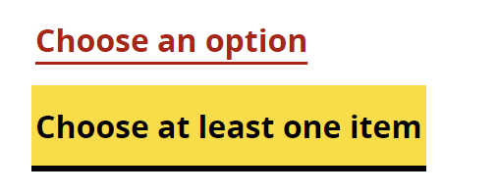

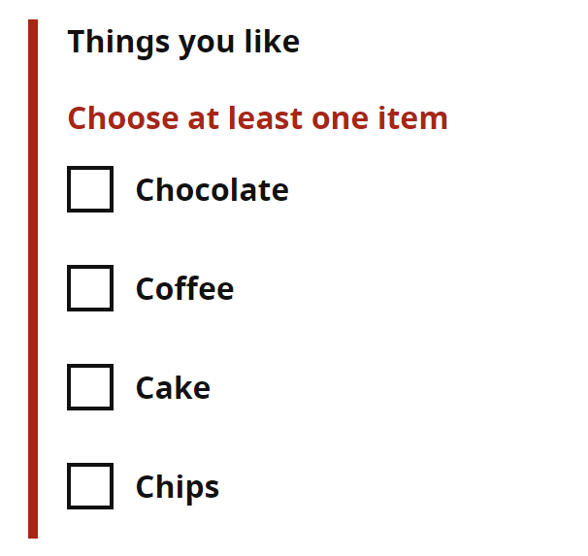

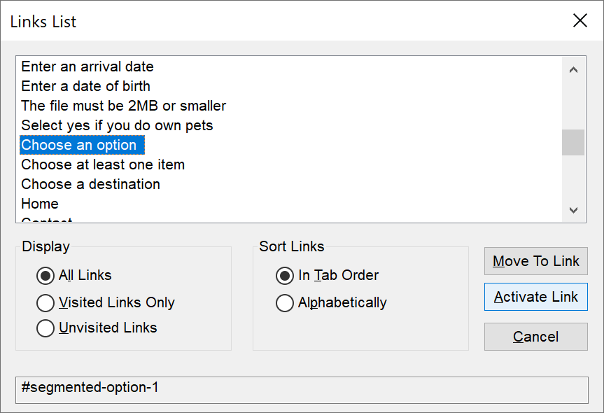

Both the error links and the inline error messages were ambiguous. ‘Choose at least option’ with no surrounding context is likely to cause confusion for users in a non-testing environment (this was an issue for our screen reader analyst).

It could also be argued that ‘Choose an option’ is ambiguous, although the radio buttons are labelled with the word ‘option’ and it may be unclear what the options relate to.

**Current code ref(s):**

<li>

<a href="#segmented-option-1">Choose an option</a>

</li>

<li>

<a href="#chocolate">Choose at least one item</a>

</li>

**Screen reader comments:**

“I located an error skip link that read to me as ‘Choose at least one item.’ It was not clear to me when situated either in or out of context which error the link related to as not enough description was included within the link text to make this obvious. Providing a more detailed description, for example ‘You must tell us the things you like’ will enable me to understand what error has occurred.

**The issue occurs with JAWS using Google Chrome and Microsoft Edge Chromium, NVDA, VoiceOver and TalkBack. Please do not focus is moved directly to the error when the link is selected.**”

**Solution:**

Provide the user with descriptive error links and inline error messages.

**Suggestions:**

‘Choose at least one item you like’

‘Choose a segmented option’

### Incorrect use of ARIA

A link is present that is not valid.

**WCAG Reference:**

4.1.2 Name, Role, Value (Level A)

[Understanding Name, Role, Value](https://www.w3.org/WAI/WCAG21/Understanding/name-role-value.html) | [How to Meet Name, Role, Value](https://www.w3.org/WAI/WCAG21/quickref/#name-role-value)

#### Issue ID: DAC-Incorrect-use-of-ARIA

URL: <https://w3c-dev.studio24.dev/posts/index.html>

Screenshot:

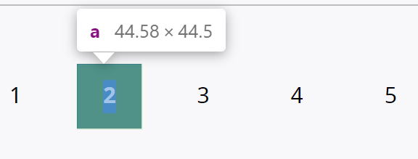

An aria-label has been used on a link that is not discoverable as a link for users of assistive technology. This is because there is no ‘href’ present to enable assistive technologies to determine that it is a link and as a result does not validate with an aria-label.

**Current code ref(s)**:

<a aria-current="page" **aria-label="page 2"**>2</a>

**Solution:**Include a ‘href’ within the link.

**Example:  
HTML**  
<a href="/" aria-current="page" aria-label="page 2">2</a>

or

<a href="/" aria-current="page">**<span class="sr-only">page</span>**2</a>

**CSS**

**.sr-only**

{

position: absolute; width: 1px; height: 1px; margin: -1px; padding: 0; overflow: hidden;

clip: rect(0,0,0,0); border: 0;

}

### Autocomplete

The autocomplete instructions were not available for some screen reading software.

**WCAG Reference:**

4.1.2 Name, Role, Value (Level A)

[Understanding Name, Role, Value](https://www.w3.org/WAI/WCAG21/Understanding/name-role-value.html) | [How to Meet Name, Role, Value](https://www.w3.org/WAI/WCAG21/quickref/#name-role-value)

#### Issue ID: DAC-Autocomplete

URL: <https://w3c-dev.studio24.dev/forms.html>

Screenshot:

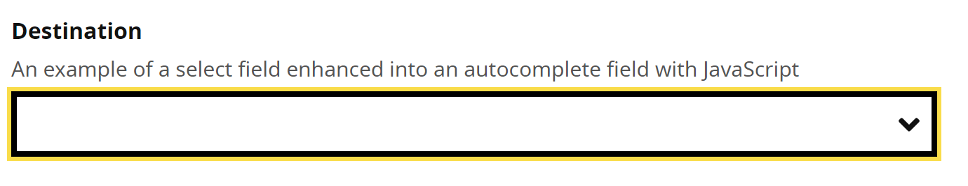

Key audible feedback from the autocomplete was missing for JAWS users using Edge Chromium and VoiceOver users. No information on how to locate the options were present, and there was no indication that options has filtered.  
  
VoiceOver users were not informed on how to interact with the component (such as by using Explore by touch).

**Current code ref(s)**:

<input aria-expanded="false" aria-owns="destination__listbox" aria-autocomplete="both" autocomplete="off" class="autocomplete__input autocomplete__input--show-all-values" id="destination" name="" placeholder="" type="text" role="combobox" aria-describedby="destination__assistiveHint">

**Screen reader comments:**

**JAWS:** browsing with Microsoft Edge Chromium I was not advised of how to locate the options using any method of navigation. Once I entered characters I was not informed that options were filtering and in a non-testing environment would not have been aware that I could filter content.

**VoiceOver**: I was advised that options were filtering once I entered characters, but no prompt advised me that I needed to explore by touch. As a highly experienced screen reader analyst I was aware of how to locate the options, but less experienced users might be unaware that they must explore by touch to locate the content.

**TalkBack:** I was given a prompt when in context of how to use the auto complete feature and could select an option.

Ensuring that screen reader users are advised on how to navigate to and select an option with all software will avoid any difficulty.”

**Issue consistent for the following pages:**

The W3C team

Journey 2 step 2

[The W3C team | W3C Redesign Prototypes (studio24.dev)](https://w3c-dev.studio24.dev/listing-people/index.html)

Members

Journey 2 step 3

<https://w3c-dev.studio24.dev/listing-members/index.html>

**Solution:**Ensure the autocomplete instructions on how to interact with the feature and its functionality when filtering options is available for all users of assistive technology.

Please refer to the [GOV.UK Design System for accessible autocomplete examples](https://alphagov.github.io/accessible-autocomplete/examples/).

### Carousel

The carousel was accessible with some minor accessibility issues encountered by our screen reader analyst.

**WCAG Reference:**

4.1.2 Name, Role, Value (Level A)

[Understanding Name, Role, Value](https://www.w3.org/WAI/WCAG21/Understanding/name-role-value.html) | [How to Meet Name, Role, Value](https://www.w3.org/WAI/WCAG21/quickref/#name-role-value)

#### Issue ID: DAC-Carousel

URL: <https://w3c-dev.studio24.dev/business/index.html>

Screenshot:

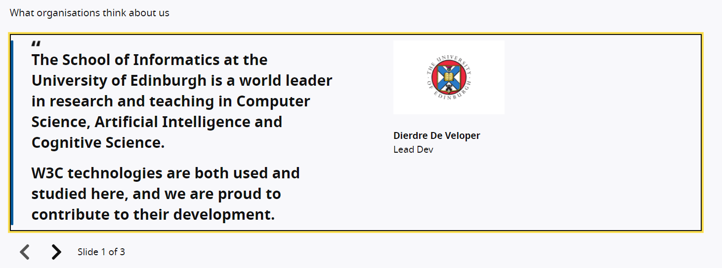

The carousel was now accessible and understandable. It was only our screen reader analyst that encounter some small usability issues.

From a technical perspective, there is an aria-label implemented on the unordered list which does not allow this attribute.

**Current code ref(s)**:

<section aria-labelledby="slider-title" aria-roledescription="carousel" class="js-slider">

<ul class="clean-list" role="presentation" tabindex="0" **aria-label="carousel content"** style="transform: translateX(0px);">

<li class="js-current" style="left: 0px;">

**Screen reader comments:**

“I found that I was able to use the carousel as the feature has become far easier to use. However there are some issues that do still remain ranging from minor to potentially problematic.

**JAWS:** using Google Chrome and Microsoft Edge Chromium I found that the slide was contained in a list of a single item. This list was not necessary as due to the amount of content in each slide it made it problematic to identify where the list ended. Removing the list would provide me with a more efficient experience. The list was not located with NVDA or VoiceOver.

While situated in context with JAWS I located a group which announced the slide number for example ‘2 of 3.’ However the phrase ‘Slide’ was not included in the group description meaning it was not immediately obvious what the numbers related to. Adding the phrase ‘Slide’ will ensure that I am able to easily understand the content.

**NVDA:** I did not locate the group or the number of the slide. I was only able to receive an indication of ‘Carousel slide’ however this did advise me that I had entered the slide, but not the number of the slide.

**VoiceOver:** I was not given an indication of where the slide began or ended. I was not advised of the group or slide number as these were not located and when swiping in context would not have been aware that I was entering a slide or viewing a carousel until I reached the carousel control buttons.

With all software when I selected the ‘Next’ and ‘Previous’ slide button my focus was taken to the top of the slide as expected and worked well.

The carousel was easy to use with JAWS with the exception of the two minor issues. NVDA was somewhat more challenging due to how the beginning of the slide announced. VoiceOver was far more challenging for me to use as I could not identify where each slide began and ended.”

**Solution:**Remove the aria-label from the unordered list. You could implement visually hidden text instead to convey this information, however, we feel there is enough information conveyed in other ways to warrant not implementing hidden text.

### *** Medium priority ***

### Resize text/ Reflow

Content becomes obscured when various screen magnification methods are implemented.

**WCAG Reference:**

1.4.4 Resize text (Level AA)

[Understanding Resize text](https://www.w3.org/WAI/WCAG21/Understanding/resize-text.html) | [How to Meet Resize text](https://www.w3.org/WAI/WCAG21/quickref/#resize-text)

1.4.10 Reflow (Level AA)

[Understanding Reflow](https://www.w3.org/WAI/WCAG21/Understanding/reflow.html) | [How to Meet Reflow](https://www.w3.org/WAI/WCAG21/quickref/#reflow)

#### Issue ID: DAC-Resize-text

URL: <https://w3c-dev.studio24.dev/posts/index.html>

Screenshot:

**Example 1**

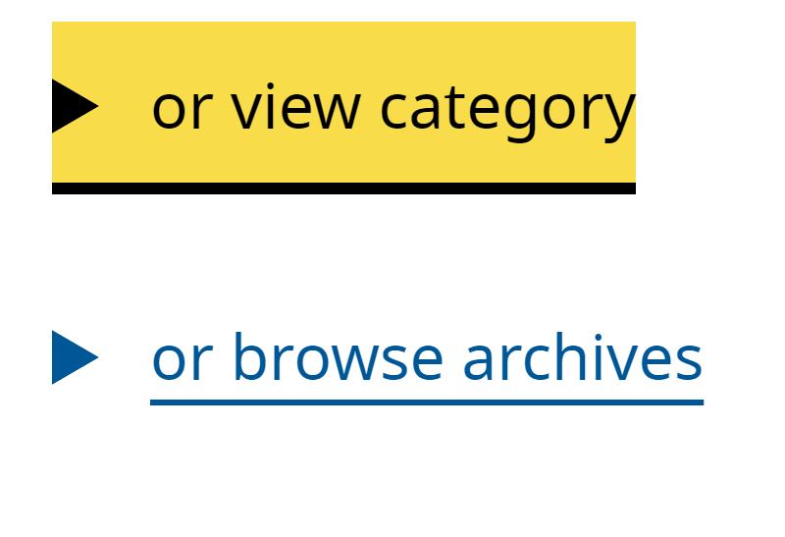

**Example 2**

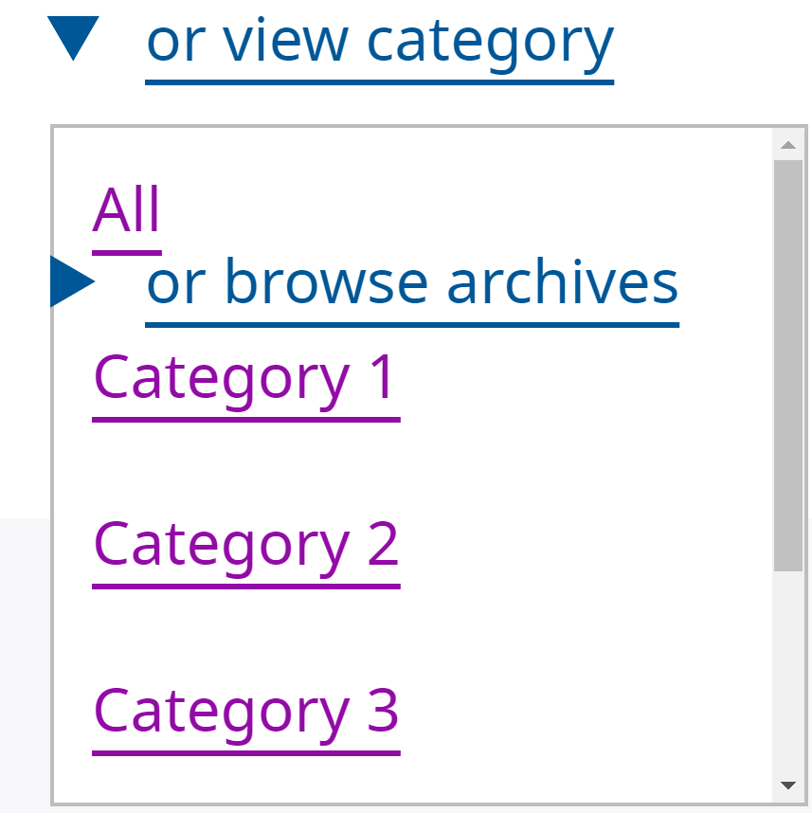

**Example 3**

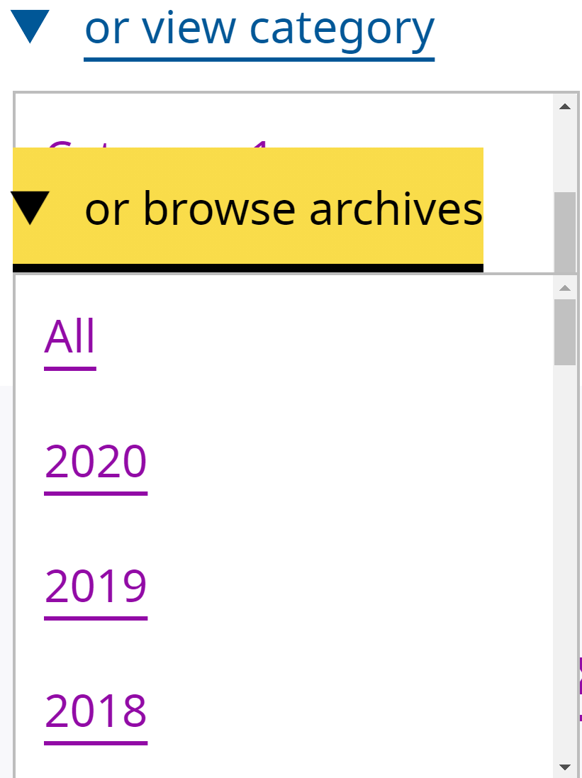

When screen magnification of 200% is implemented on a standard size laptop and the first details component is initiated, the label from the second details component ‘or browse archives’ is visible and appears to be part of the ‘or view category’ details component.

Additional issues arise if the user mistakenly selects the ‘or browse archives’ once the component was open, as this then obscures other content (please see example 3 screenshot).

This was disorientating for our low vision analyst and will be problematic in a non-testing environment, as components are stacked.

**Please note:** this is not an issue when magnifying the page to 200% on larger displays; however, most users in a non-testing environment will likely be on a standard laptop. The issue was also present when implementing the reflow technique.

The reflow technique is when the user manipulates the viewport to 1280px and magnifies the page to 400%. This helps users with a visual impairment to enlarge the text on the page to be able to read it in a single column.

**Widescreen display monitor**

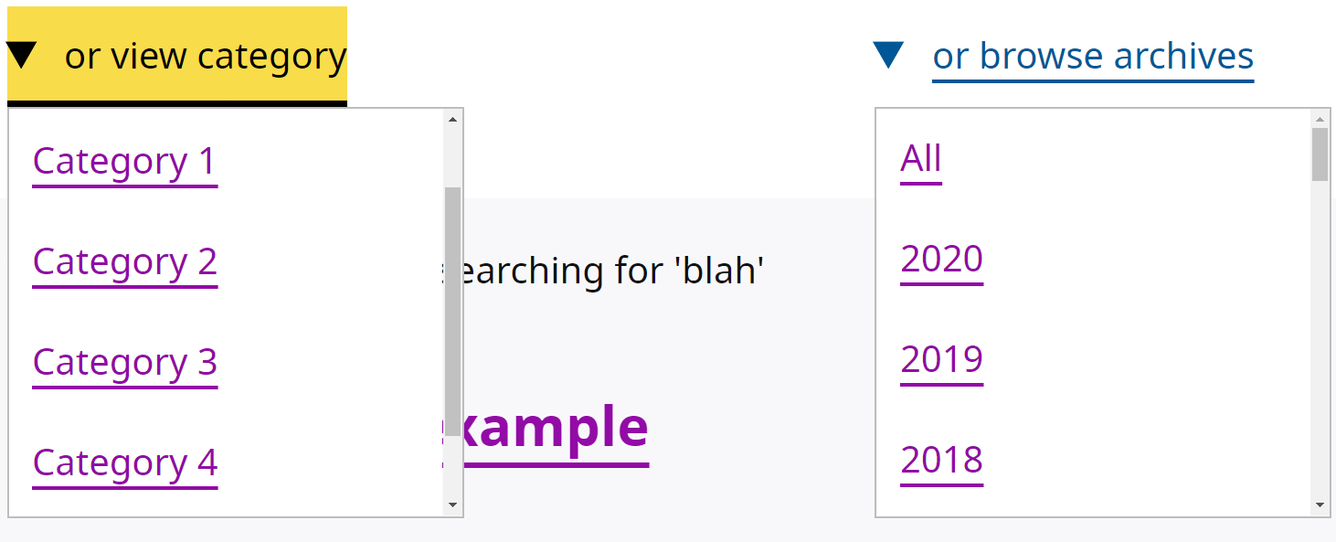

**Current code ref(s)**:

<details open="">

<summary>

<span>or view category</span>

</summary>

<ul class="clean-list" role="list" tabindex="0" aria-labelledby="category-heading">

<li><a href="../page.html">All</a></li>

<li><a href="../page.html">Category 1</a></li>

<li><a href="../page.html">Category 2</a></li>

<li><a href="../page.html">Category 3</a></li>

<li><a href="../page.html">Category 4</a></li>

<li><a href="../page.html">Category 5</a></li>

</ul>

</details>

**Low vision comments:**

“On the posts page below the show results button, there are 2 dropdowns ‘or view category’ and ‘or browse archives’ when clicking on the ‘or view category’ dropdown ‘or browse archives’ overlapped the dropdown. I was really confused by this and was unsure why this was happening.”

**Solution:**Ensure [text](https://www.w3.org/TR/WCAG21/#dfn-text) can be resized without [assistive technology](https://www.w3.org/TR/WCAG21/#dfn-assistive-technologies) up to 200 percent without loss of content or functionality.

We recommend providing adequate spacing between each component, so that content within the first details component does not obscure the other.

### Duplicated buttons

There were duplicated buttons on the page.

**WCAG Reference:**

2.4.6 Headings and Labels (Level AA)

[Understanding Headings and Labels](https://www.w3.org/WAI/WCAG21/Understanding/headings-and-labels.html) | [How to Meet Headings and Labels](https://www.w3.org/WAI/WCAG21/quickref/#headings-and-labels)

#### Issue ID: DAC-Duplicated-buttons

URL: <https://w3c-dev.studio24.dev/posts/post.html#respond>

Screenshot:

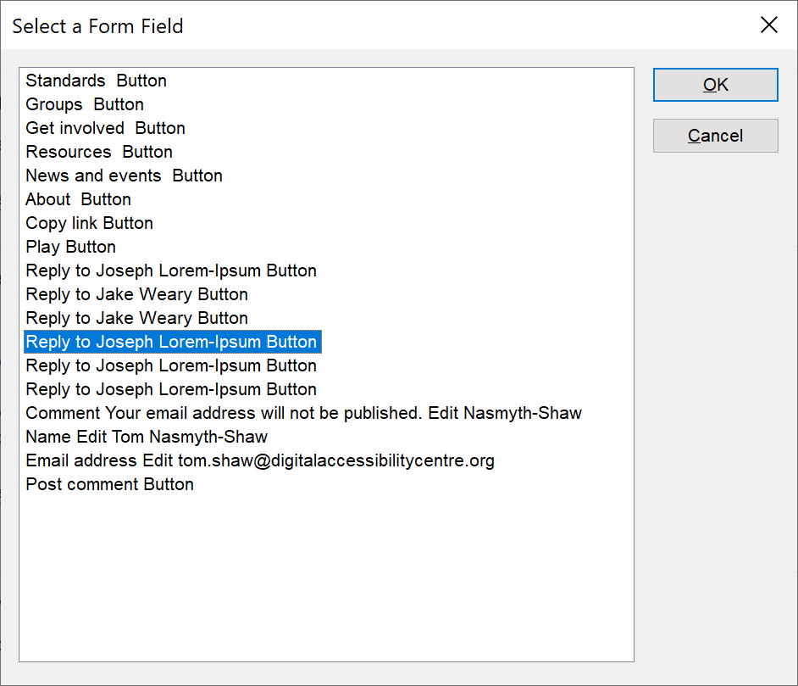

There are a number of duplicated buttons that perform different functions. For example: there is a button to reply to Jake Weary when in fact the user is replying to Celeste Magritte.

This issue is highly problematic for screen reader users browsing both in and out of context.

**Current code ref(s)**:

<button class="button button--ghost" data-replylink="" data-commentid="204687" data-postid="18930" data-belowelement="comment-204687" data-replyto="Reply to Jake Weary">Reply <span class="visuallyhidden">to Jake Weary</span></button>

<button class="button button--ghost" data-replylink="" data-commentid="345071" data-postid="18930" data-belowelement="comment-345071" data-replyto="Reply to Celeste Magritte">Reply <span class="visuallyhidden">to Jake Weary</span></button>

**Screen reader comments:**

“I found that the ‘Reply’ buttons were duplicated both in and out of context. Although the reply options did possess the name of the individual being replied to, these names did not always match the comment they were associated with which was confusing and made it difficult for me to identify who I was replying to. Ensuring that each button is given a unique label and matches the relevant comment will prevent any confusion. The issue is consistent with JAWS using Google Chrome and Microsoft Edge Chromium, NVDA, VoiceOver and TalkBack.”

**Solution:**

Change the visually hidden button text on all buttons to reflect who the user is replying to. **Example:**

<button class="button button--ghost" data-replylink="" data-commentid="204687" data-postid="18930" data-belowelement="comment-204687" data-replyto="Reply to Jake Weary">Reply <span class="visuallyhidden">to Jake Weary</span></button>

<button class="button button--ghost" data-replylink="" data-commentid="345071" data-postid="18930" data-belowelement="comment-345071" data-replyto="Reply to Celeste Magritte">Reply <span class="visuallyhidden">to **Celeste Magritte** </span></button>

### Non-descriptive heading

The heading and its meaning may be ambiguous for some users.

**WCAG Reference:**

2.4.6 Headings and Labels (Level AA)

[Understanding Headings and Labels](https://www.w3.org/WAI/WCAG21/Understanding/headings-and-labels.html) | [How to Meet Headings and Labels](https://www.w3.org/WAI/WCAG21/quickref/#headings-and-labels)

#### Issue ID: DAC-Non-descriptive-heading

URL: <https://w3c-dev.studio24.dev/posts/post.html#respond>

Screenshot:

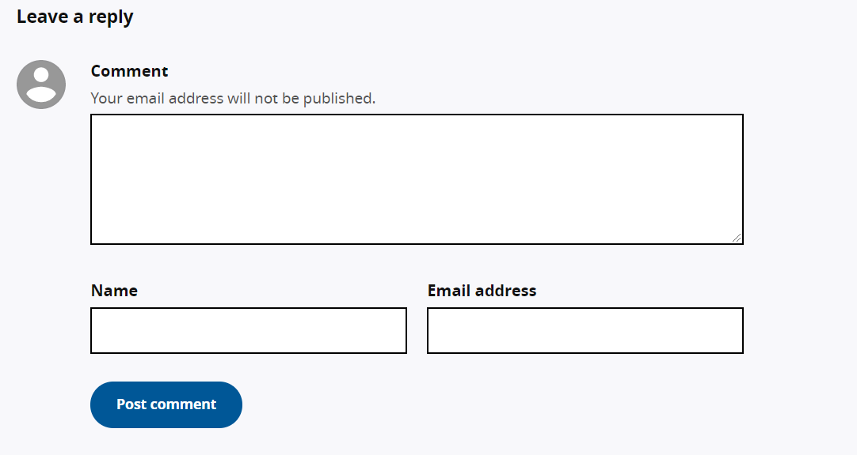

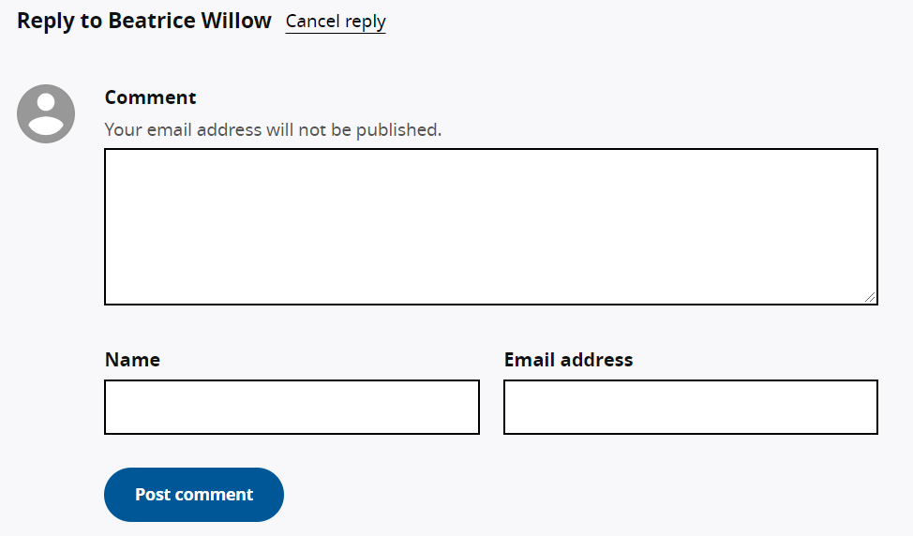

The heading entitled ‘Leave a reply’ may be ambiguous for some users and conflicting in some instances. This is because there are many ways to leave a reply to various people; however, the replying function at the bottom of the page appears to be to leave a new comment, as opposed to reply to a specific person.

**Current code ref(s)**:

<h3 class="txt-saturn" data-title="reply">Leave a reply</h3>

**Screen reader comments:**

“I located a section on the page where I could leave a comment. However, the heading to introduce the section announced to me as ‘Leave a reply.’ This was highly confusing as it was not obvious where I could create a new comment. This was made more confusing as when I selected one of the ‘Reply’ buttons the page updated to display the same fields that were originally present on the page only related to the individual comment. I would find it helpful if the heading could be changed to clearly indicate that the section is leave a general reply or to create a new reply.

**The issue occurs with JAWS using Google Chrome and Microsoft Edge Chromium, NVDA, VoiceOver and TalkBack.**”

**Solution:**

You could amend the heading so that it is more specific.

**Suggestion:**<h3 class="txt-saturn" data-title="reply">Create a new comment</h3>

### *** Low priority ***

### Ambiguous links

The pagination links were ambiguous for screen reader users browsing out of context.

**WCAG Reference:**

2.4.9 Link Purpose - Link Only - (Level AAA)

[Understanding Link Purpose (Link Only)](https://www.w3.org/WAI/WCAG21/Understanding/link-purpose-link-only.html) | [How to Meet Link Purpose (Link Only)](https://www.w3.org/WAI/WCAG21/quickref/#link-purpose-link-only)

#### Issue ID: DAC-Ambiguous-link

URL: <https://w3c-dev.studio24.dev/posts/index.html>

Screenshot:

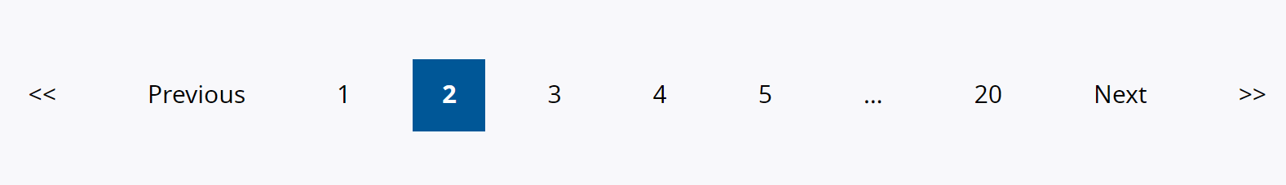

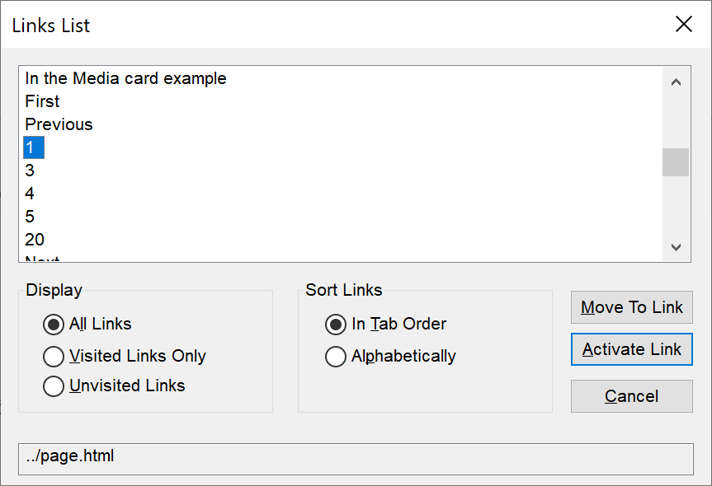

The pagination links will be ambiguous for screen reader users browsing out of context. It is not clear what 1/3/4/5… relate to for example. This is also applicable for the ‘Previous’ and ‘Next’ links. Additional information is required to give the links more context.

**Current code ref(s)**:

<a href="../page.html">1</a>

**Screen reader comments:**

“While situated out of context I located a series of links for example ‘Last’ and ‘Next’ and multiple links announcing as numbers. Although in context I was able to easily establish that the links related to a pagination this was not as clear when situated out of context. As a highly experienced screen reader user and analyst I could understand the content, but less experienced screen reader users may not be aware of what is being selected. Adding the phrase ‘Page’ at the beginning or end of each pagination link will enable users to make an informed selection both in and out of context.

**The issue is present with JAWS using Google Chrome and Microsoft Edge Chromium, NVDA, VoiceOver and TalkBack.**”

**Issue consistent for the following pages:**Events  
Journey 1 step 4  
<https://w3c-dev.studio24.dev/listing-events/index.html>

Members

Journey 2 step 3

<https://w3c-dev.studio24.dev/listing-members/index.html>

**Solution:**

Provide descriptive hidden text so that screen reader users can understand the purpose of each pagination link while browsing out of context.

This can be done by using a hidden span, or by using an aria-label.

**Example:**

**HTML**  
<a href="../page.html">**<span class="sr-only">page</span>**1</a>

**CSS**

**.sr-only**

{

position: absolute; width: 1px; height: 1px; margin: -1px; padding: 0; overflow: hidden;

clip: rect(0,0,0,0); border: 0;

}

or

**Aria-label**  
<a **aria-label="Go to page 1"** href="../page.html">1</a>

### *** Usability ***

### Labels

The labels are extensive.

**WCAG Reference:**

Usability

#### Issue ID: DAC-Labels

URL: <https://w3c-dev.studio24.dev/forms.html>

Screenshot:

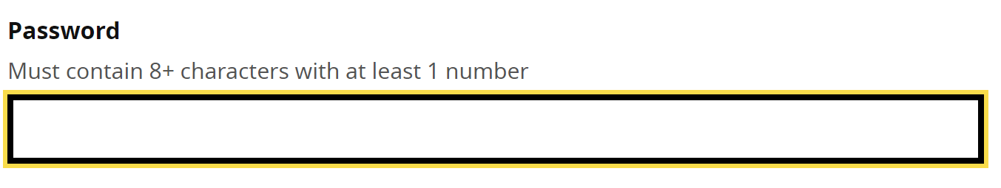

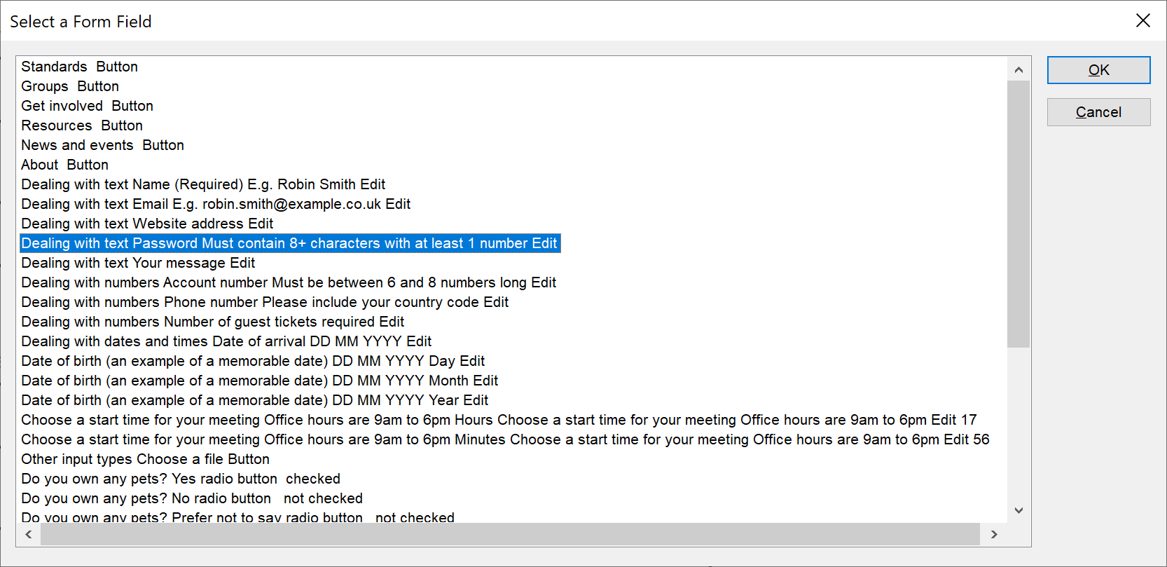

Our screen reader analyst testing the page felt that the labels provided an over-abundance of information within the label, which can be a lot for a screen reader user to decipher.

Hint text is often situated outside of the label; however, in some cases it is associated with the input using aria-describedby. This technique ensures the hint text is discoverable when browsing with the tab key or by using software shortcuts when the input receives focus.

**Please note:** this was not an accessibility barrier and including hint text within the label may actually be beneficial to other screen reader users in a non-testing environment.

**Current code ref(s)**:

<label for="password">

<span class="field-label">Password</span>

**<span class="field-hint">Must contain 8+ characters with at least 1 number</span>**

</label>

**Screen reader comment 1:**

“Within the labels of multiple input fields for example the ‘Name field I located hint information such as ‘e.g. Robin Smith.’ This information made the labels longer to read. I also found it more problematic for some fields to identify where the purpose of the label ended, and the hint text began. Although in some instances it is helpful to have the hint content within the label, it would also benefit screen reader users if the hint content could be separated from the label and could be associated to the input field using aria describedby which will provide me with a concise and efficient label. **The issue occurs with JAWS using Google Chrome and Microsoft Edge Chromium, NVDA, VoiceOver and TalkBack.**”

**Issue consistent for the following pages:**

A post – Comment field

Journey 1 step 3

<https://w3c-dev.studio24.dev/posts/post.html#respond>

**Screen reader comment 2:**

“**JAWS:** using both Google Chrome and Microsoft Edge Chromium I found that the ‘Password’ field both in and out of context appeared to announce to me as an instruction reading as ‘Password must contain eight plus characters with at least one number.’ This made it more challenging for me to understand that this label was the purpose of the field and not the instruction.

**NVDA:** while browsing in context I discovered the purpose on the first line followed by the hint content on the second making the content clear. However when I viewed the field using the elements list ‘Insert + f7’ the item consistent with JAWS announced as a single item.

**VoiceOver:** while swiping in context I located the phrase ‘Password’ on the first line with the phrase repeated on the second line prior to the hint content. It was not obvious why the phrase ‘Password’ announced twice to me.

Ensuring that the purpose of the field and the hint content are separated will prevent any potential confusion and ensure that I am easily able to identify both the purpose of the field and the hint information.

**TalkBack:** Consistent.

Please note that similar functionality occurs for other fields throughout the page.”

**Solution:**We recommend that the hint text is separate by placing this outside of the label and associating the text with the input by using aria-describedby.

**Example:**

<div class="field">

<label for="name">

<span class="field-label">Name <span class="required">(Required)</span></span>

</label>

<span **id="example"** class="field-hint">E.g. Robin Smith</span>

<input **aria-describedby="example"** type="text" id="name" name="name" autocomplete="name">

</div>

### Fieldset & legend

The fieldset and legend was not required.

**WCAG Reference:**

Usability

#### Issue ID: DAC-Fieldset-&-legend

URL: <https://w3c-dev.studio24.dev/forms.html>

Screenshot:

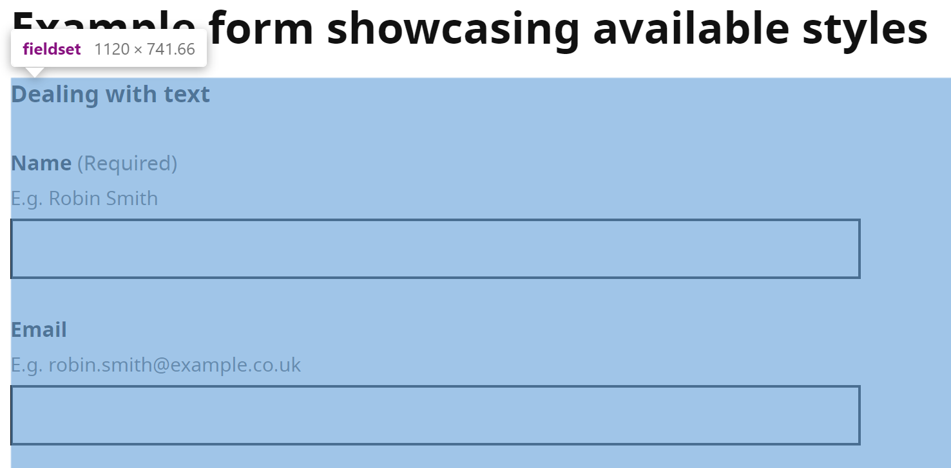

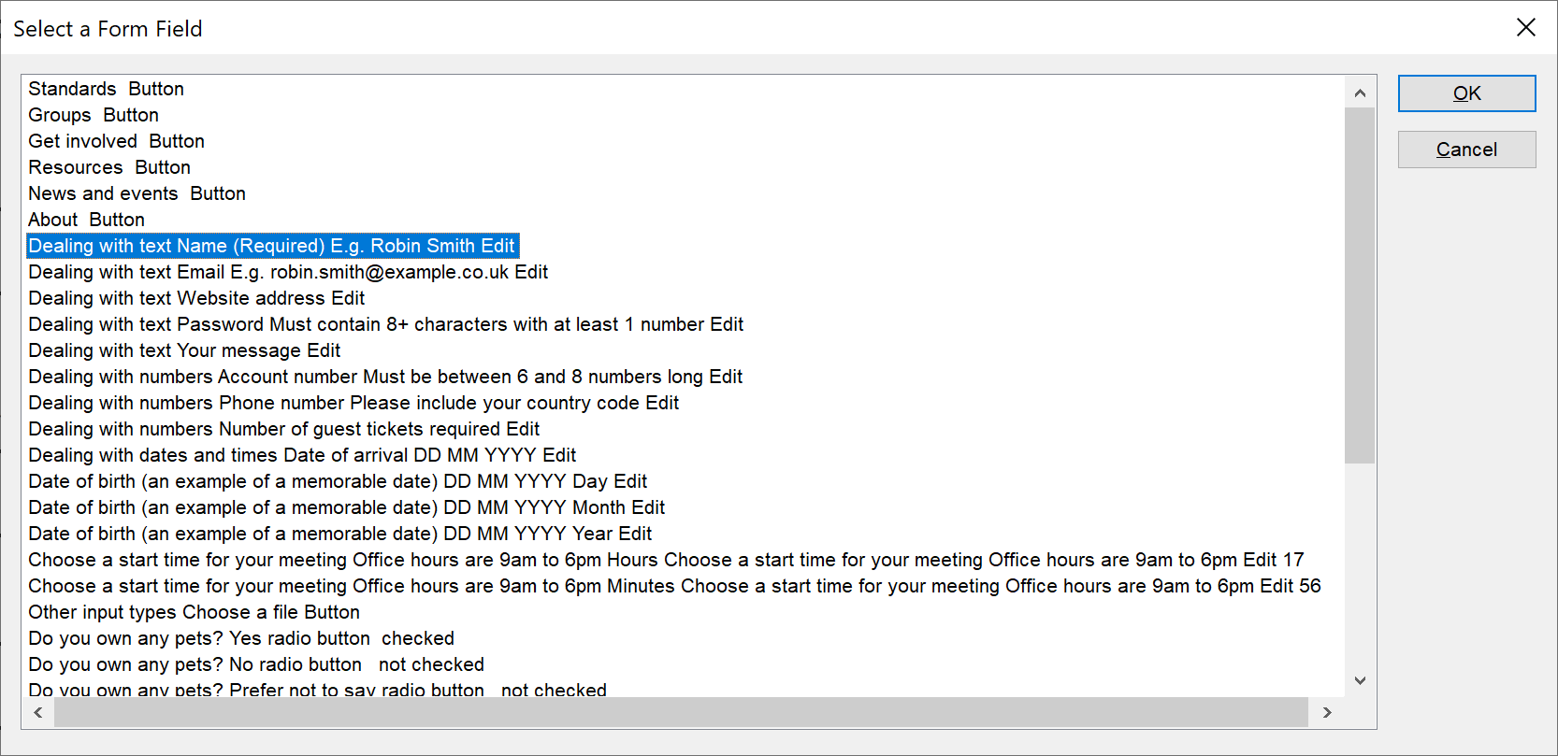

There are numerous areas of the page entitled ‘Dealing with text’ and ‘Dealing with numbers’ ‘Dealing with dates and times’ and ‘Other input types’ that have been marked up as part of a fieldset and legend, which does not group together information in a way that is understandable for the end user.

This is probably due to the nature of the page, but it should be noted that the <legend> text must describe the group of related fields.

Nested fieldset elements can cause confusion for screen reader users where the first legend is read out in association with the input but not the second that it is nested in.

In a ‘live’ situation we would recommend using a heading to introduce sections; such as ‘Dealing with dates and times’ and the fieldset and legend around the ‘Date of birth’ for example, as being more descriptive.

Aria-describedby can be used to reference the hint text on the <fieldset> where the hint text applies to the group.

**Current code ref(s)**:

<fieldset>

<legend>

<span class="field-legend">Dealing with text</span>

</legend>

**Screen reader comment 1:**

“While browsing out of context I located a legend within the field set and legend feature that read to me as ‘Dealing with text.’ It was not obvious to me while browsing out of context what this indicated. Providing a clear description for example ‘Your details’ will enable me to make an informed selection both in and out of context. Please note that the issue is consistent for similar legend descriptions throughout the page.

**The issue is consistent with JAWS using Google Chrome and Microsoft Edge Chromium, and NVDA. Please note the issue is also consistent while swiping in context with VoiceOver; however, the VoiceOver rotor does not presently support field set and legend functionality when situated out of context. Field set and legend functionality is not supported with TalkBack; however, I can locate the text while situated in context with this software.”**

**Screen reader comment 2:**

“I found that a fieldset and legend feature was situated inside of another fieldset and legend feature as the fieldset and legend for the section ‘Dealing with dates and times’ surrounded the fieldset and legend relating to ‘Choose a start time for your meeting. In context this made it more challenging to identify where one group ended and the next began.

**JAWS:** using both Google Chrome and Microsoft Edge Chromium and the JAWS form fields dialog menu ‘Insert + f5’ the legend ‘Dealing with dates and times’ did not announce with only the ‘Choose a start time for your meeting’ announcing. Although this did make it clear what the items related to I did not receive all information using this method of navigation.

**NVDA:** the ‘f’ key to view the fieldset and legend item displayed the same functionality As JAWS.

**VoiceOver:** while swiping in context I was not able to locate an additional fieldset surrounding the ‘Choose a start time for your meeting’ however the fieldset ended on the element.

Although it is acknowledged that screen reading software is not presently able to announce multiple legends simultaneously removing the fieldset and legend for ‘Dealing with dates and times’ will enable me to easily locate the other fieldset and legend content. The issue is not applicable to TalkBack as this software does not presently support field set and legend. Please note the issue is consistent for other fieldset groups throughout the page.”

**Screen reader comment 3:**“The feature for ‘Date of arrival’ was not situated within a fieldset and legend specific to its purpose. Although there was an overall fieldset and legend for ‘Dealing with dates and times’ this did not clearly indicate the specific purpose of each item. Instead I found that the information relating to the overall purpose of the feature was included within each field label along with the ‘Day,’ ‘Month’ and ‘Year’ content depending on the individual field or spin button. This made it more time consuming for me to identify each field especially when browsing out of context. I would find it helpful if the fieldset and legend for ‘Dealing with dates and times’ could be removed, with a fieldset and legend instead surrounding the ‘Date of arrival’ content. Removing the overall purpose from the label and including it within the legend would also provide me with an easier and more efficient experience. The issue was consistent with JAWS using Google Chrome and Microsoft Edge Chromium, and also with NVDA. The issue is not applicable to VoiceOver or TalkBack.”

**Solution:**Avoid nesting <fieldset> elements where possible.

Ensure that <legend> text is descriptive.

Consider using aria-describedby on the <fieldset> that references the hint text related to the group.

### Calendar 1

The calendar item may be time-consuming to navigate for some users.

**WCAG Reference:**

Usability

#### Issue ID: DAC-Calendar-issue1

URL: <https://w3c-dev.studio24.dev/forms.html>

Screenshot:

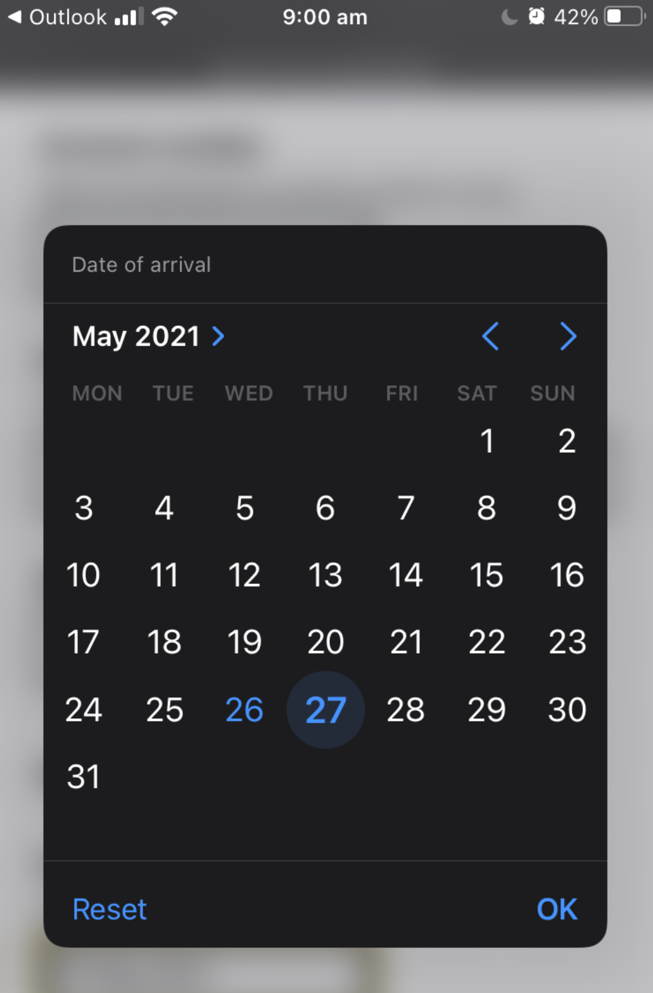

Although the calendar item worked very well from an accessibility perspective, our screen reader analyst felt that it was time-consuming to have to swipe through all of the options.

**Current code ref(s)**:

<input type="date" class="input-width-10" id="arrival-date" name="arrival-date">

**Screen reader comments:**

“With VoiceOver the feature to select a date of arrival was a pop-up button. Once I selected the button I was taken to a menu where a picker item allowed me to select the month, and then swipe through all dates within the month to select the required date.

With TalkBack the functionality behaved in a similar manner; however, when I selected a date the picker did not collapse. After further exploration I discovered that there was a further button that I needed to select at the end of the calendar month to submit the date, but I was not immediately aware of this and became confused.

Although I was able to perform this task it was highly time consuming especially if the required date as at the end of the month. I was not provided with an option to enter the date manually. I would find it helpful if input fields could be provided instead as this would provide me with a more efficient experience and require less swipes of the keyboard. The question page pattern of the GOV.UK Design System provides me with an easy and efficient method of entering a date. The issue is not applicable to JAWS or NVDA.”

**Solution:**No solution required. A consideration could be to allow the user to manually input their own date or arrival via a standard text input.

### Calendar 2

The date input was problematic for some screen reading software.

**WCAG Reference:**

Usability

#### Issue ID: DAC-Calendar-issue2

URL: <https://w3c-dev.studio24.dev/forms.html>

Screenshot:

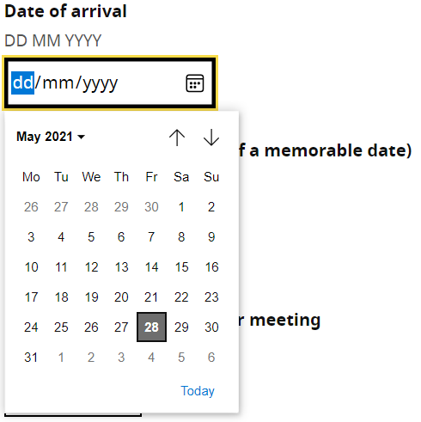

The calendar item was predominantly difficult to use for our screen reader analyst browsing in Edge Chromium. An audible cue is present alerting the user that a grid has appeared, but the user cannot interact with the calendar in the grid format (like Google Chrome users can).

**Please note:** an alternative way is available whereby the user can interact with the calendar successfully using table shortcuts.

The button is not discoverable using NVDA with Firefox, although the calendar can be activated using the space bar. The calendar is not accessible for NVDA users.

Our low vision analyst also found the calendar problematic when the page was magnified to 400% for reflow purposes. The calendar could not be viewed by scrolling up and down the page using the mouse. The user had to close the calendar and move focus up/ down to be able to view the calendar in its entirety.

**Current code ref(s)**:

<input type="date" class="input-width-10" id="arrival-date" name="arrival-date">

**Screen reader comments:**

“I selected the ‘Show date picker’ button relating to the ‘Date of arrival.’

With JAWS using Microsoft Edge Chromium my focus was taken to the calendar. However, when I attempted to use the arrow keys to move around the table I was taken out of the grid. Although my focus remained in the table I was not able to use the ‘Left’ or ‘Right’ arrow keys to move around the dates. I needed to use the standard table shortcut commands of ‘Control + alt + arrow keys’ to move around the table which made it more time consuming for me to locate the next and previous months. Once I selected a date my focus moved back to the ‘Show date picker’ item as expected.

With JAWS and Google Chrome focus was taken to the calendar with my focus remaining in the grid. I was able to use the arrow keys to move around the calendar and easily select a date. Once the date was selected my focus moved back to the ‘Show date picker’ button. However I found that the button also announced as a menu and kept my focus within the menu. I needed an additional key selection of ‘Escape’ to exit the menu which could confuse some screen reader users.

I was not able to locate the ‘Show date picker’ button using NVDA and could not access the calendar content.

I would find it helpful if the calendar could be hidden from screen reader users as it makes selecting a date more problematic and time consuming. Allowing users to enter the date manually is more efficient and easier to perform. This issue is not applicable to VoiceOver or TalkBack.”

**Low vision comments:**“When on the calendar popup, I found navigating it difficult, by difficult I mean, when scrolling to try and get to the top of the Calendar when magnifying the page to 400% and changing the browser width to 1280x1024px, you are not able to as the page is locked unless your mouse pointer is on the main page but then when you do manage to scroll up the page the calendar disappears. You have to scroll up the page and then go back to the Calendar to try and see if you have managed to get to the top, this makes navigation hard and frustrating. Please note: I was faced with a similar issue with the ‘Choose a start time for your meeting’ input.”

**Solution:**We would recommend using a standard text input to allow users to enter dates of any kind i.e. the date of arrival.

### Details component 1

The details component was not discoverable for some users of assistive technology.

**WCAG Reference:**

Usability

#### Issue ID: DAC-Details-component-issue1

URL: <https://w3c-dev.studio24.dev/posts/index.html>

Screenshot:

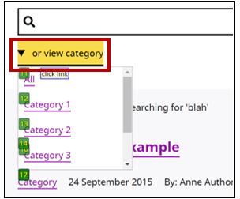D

The details component is not discoverable for voice activation users using standard commands; such as “Click link” or “Click button” meaning commands such as “Press tab” or “Mouse grid” must be used, which can be time-consuming.

Another issue Dragon users will encounter is being able to interact with the links situated within the component. An internal scroll is present, which is often problematic for this user group.

Additional steps must be taken to gain focus within the component; such as saying the “Press tab” command before the user can scroll through the options by using the “Move page down” command for example. Again, this can be time-consuming for the user especially when there are a high number of links found within the ‘or browse archives’ component.

VoiceOver users were also unable to locate this feature with Apple’s built in Rotor feature.

**Please note: Internet Explorer users are presented with components that are already expanded.**

**IE11 example**  
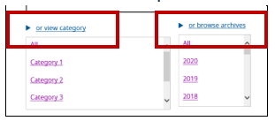

**Current code ref(s)**:

<details>

<summary>

<span>or view category</span>

</summary>

<ul class="clean-list" role="list" tabindex="0" aria-labelledby="category-heading">

<li><a href="../page.html">All</a></li>

<li><a href="../page.html">Category 1</a></li>

<li><a href="../page.html">Category 2</a></li>

<li><a href="../page.html">Category 3</a></li>

<li><a href="../page.html">Category 4</a></li>

<li><a href="../page.html">Category 5</a></li>

</ul>

</details>

**Screen reader comment (mobile):**

“While situated in context with VoiceOver I located multiple details component features for example ‘Or view category.’ I was not able to locate the items out of context with the rotor as the details component items did not announce as links or buttons. I would not have been aware when situated out of context that the items were present.

Some screen reader users may also be unaware in context that the items were selectable, although an aria prompt does advise users that the item is collapsed or expanded. Providing the item as a button will ensure I can make an informed selection both in and out of context.”

**Issue consistent for the following pages:**

Events

Journey 1 step 4

<https://w3c-dev.studio24.dev/listing-events/index.html>

**Voice activation comment 1:**

“I am able to access the links within the internal scroll, by using mouse commands to move my focus into the blank space of the internal scroll to gain focus. then using the command page up/ down so I can see more of the links, then using label by name to access the link I need. It would be much easier and faster for users if they were standard combo boxes where users could use the more standard commands of click box shows, go down three lines (or even tick boxes would easier).”

**Consistent on the following page:**  
<https://w3c-dev.studio24.dev/listing-events/index.html>

**Voice activation comment 2:**

“Both the expandable links appear open when the page loads in IE11. This could confuse users as they would expect them to be closed when the page loads, and then to open them with label by name. Because they already open and the Chevron haven’t changed direction users could think that they are still closed and that there is more information to see.”

**Consistent on the following page:**

<https://w3c-dev.studio24.dev/listing-events/index.html>

**Solution:**

Add a role of button to the component to ensure that users of assistive technologies can access and interact as expected.

### Details component 2

The details component was confusing for some of our testing team.

**WCAG Reference:**

Usability

#### Issue ID: DAC-Details-component-issue2

URL: <https://w3c-dev.studio24.dev/posts/index.html>

Screenshot:

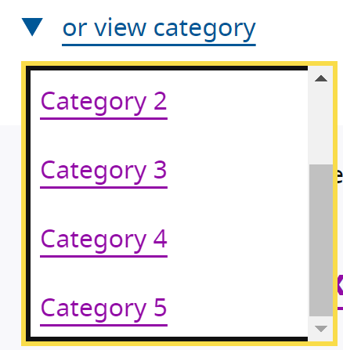

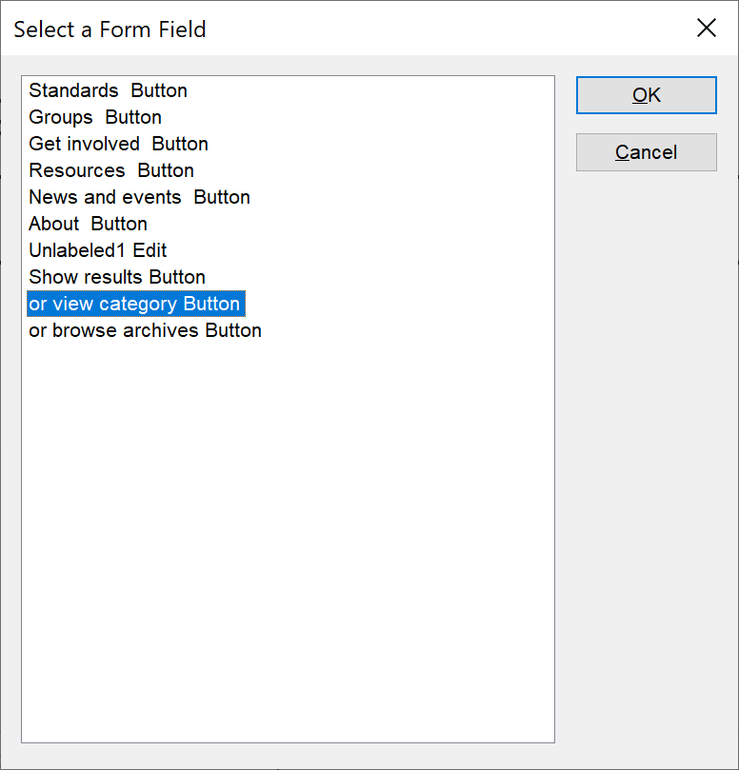

The only issue with the details component in this format is that our team of analysts is that it was not presented in a way which is usually expected for this type of component. The issues identified overall were usability related.

Typically with this type of component users do not expect to initiate it and then interact with the component as a whole. Once opened, the user would usually interact with the content situated within.

Another issue for our screen reader analyst was the use of the word ‘or’ which was confusing.

**Current code ref(s)**:

<section class="category-links">

<h2 id="category-heading" class="visuallyhidden">W3C post categories</h2>

<details>

<summary>

<span>or view category</span>

</summary>

<ul class="clean-list" role="list" tabindex="0" aria-labelledby="category-heading">

<li><a href="../page.html">All</a></li>

<li><a href="../page.html">Category 1</a></li>

<li><a href="../page.html">Category 2</a></li>

<li><a href="../page.html">Category 3</a></li>

<li><a href="../page.html">Category 4</a></li>

<li><a href="../page.html">Category 5</a></li>

</ul>

</details>

</section>

**Screen reader comment 1:**

“I located a heading which announced to me as W3C post categories and a separate details component of ‘Or view category.’ The details component when situated out of context caused me some confusion as due to the phrase ‘Or’ I expected to locate other content that was selectable. It was not obvious why the heading and details component were separated. Providing the details component as a heading will enable me to identify the heading and details component as a single item to make my selection both in and out of context without any confusion.

**The issue is present with JAWS using Google Chrome and Microsoft Edge Chromium, NVDA and TalkBack. Please note: the issue is only consistent when swiping in context with VoiceOver. The issue occurs for other details component items on the page.”**

**Issue consistent for the following pages:**

Events

Journey 1 step 4

<https://w3c-dev.studio24.dev/listing-events/index.html>

**Screen reader comment 2:**

“I expanded the two details components for ‘Or view category’ and ‘Or browse archive.’ A piece of text appeared directly after the details component once the content was expanded which was descriptive while in context.

**JAWS:** using Google Chrome and Microsoft Edge Chromium when I used the ‘Tab’ key this text received focus. The text was not selectable and did not change the page content selected. This could cause confusion as some users may believe the text is selectable.

**NVDA:** the text also received focus, however in addition to JAWS/ NVDA announces the whole list of links as a single item which could confuse some users. I explored further and discovered that I was able to tab to all of the links.

Ensuring that the text is not located within the tab order will prevent any potential confusion.

**VoiceOver:** please note that the text is not located neither in or out of context.

**TalkBack:** although the tab key is not applicable, I am able to locate the text within the controls menu which could confuse some users as the item is not selectable and does not perform an action.”

**Issue consistent for the following pages:**

Events

Journey 1 step 4

<https://w3c-dev.studio24.dev/listing-events/index.html>

**Screen reader comment 3:**

“While situated in context with VoiceOver I located multiple details component features for example ‘Or view category.’ I was not able to locate the items out of context with the rotor as the details component items did not announce as links or buttons. I would not have been aware when situated out of context that the items were present. Some screen reader users may also be unaware in context that the items were selectable, although an aria prompt does advise users that the item is collapsed or expanded. Providing the item as a button will ensure I can make an informed selection both in and out of context. **The issue is not present with JAWS, NVDA or TalkBack.**”

Issue consistent for the following pages:

Events

Journey 1 step 4

<https://w3c-dev.studio24.dev/listing-events/index.html>

**Keyboard-only comments:**

“After I open the expandable link, my focus goes into the list as whole before tabbing onto the links themselves. This is unusual and users would not expect their highlight focus to go onto the links and not the box. The highlighting on the box could confuse users into thinking it could be extended again.”

**Consistent on the following page:**

<https://w3c-dev.studio24.dev/listing-events/index.html>

**Solution:**

You could use standard select elements to convey this information to users. Consider removing the word ‘or’ from the labelling.

### Numerical limit

Capping the amount of numbers that can be entered, may be beneficial for screen reader users.

**WCAG Reference:**

Usability

#### Issue ID: DAC-Numerical-limit

URL: <https://w3c-dev.studio24.dev/forms.html#main>

Screenshot:

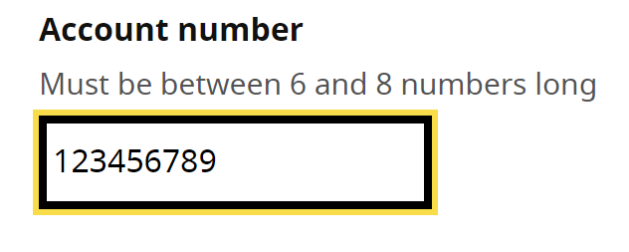

Allowing the user to input too many numbers may cause the user to make unnecessary mistakes especially screen reader users.

**Current code ref(s)**:

<input type="text" class="input-width-10" id="account-number" name="account-number" pattern="[0-9]*" inputmode="numeric">

**Screen reader comments:**

“The ‘Account number’ input field advised me that between six and eight numbers could be entered. However I intentionally entered more than eight characters into the field and discovered that the numbers could be entered. This would mean in a non-testing environment that too many characters were entered. Ensuring that a limit is placed on the number of digits that can be entered for this field will prevent any potential confusion. **The issue is consistent with JAWS using Google Chrome and Microsoft Edge Chromium, NVDA, VoiceOver and TalkBack.**”

**Solution:**Consider using the ‘maxlength’ attribute to only allow users to input 8 numbers.

**Suggestion:**<input **maxlength="8"** type="text" class="input-width-10" id="account-number" name="account-number" pattern="[0-9]*" inputmode="numeric">

### Problematic input 1

The date input was problematic for some screen reader software.

**WCAG Reference:**

Usability

#### Issue ID: DAC-Problematic-input-issue1

URL: <https://w3c-dev.studio24.dev/forms.html>

Screenshot:

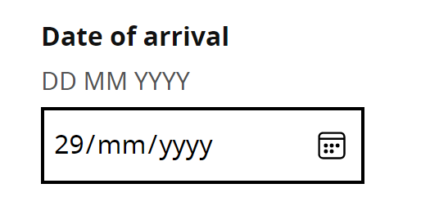

The functionality of the input differed between each software and browser. Our screen reader analyst found the Edge Chromium browser problematic when trying to interact with the input using the tab key. It was not known by the analyst that the left/ right arrow keys could be used.

Some NVDA users may find interacting with the input problematic while browsing in context; however, there are other methods of navigation; such as using the left/ right arrow keys and pressing the tab key. The shift in auto focus may also help some users.

Dragon users are unable to access the input using standard commands; however, they can access this in other ways by using additional command such as “Press tab” or “Mouse grid” - the user should also be able to speak the label with focus being taken to the input directly. This is consistent for the ‘Choose a start time’ input.

The <span> inside the label entitled DD MM YYY appears to be interfering with the Dragon software and stops the user from speaking the label; without the span the user can access it using this method.

Overall it appears that the input type ‘date’ can be problematic for some assistive for some assistive technology.

**Current code ref(s)**:

<div class="field">

<label for="arrival-date">

<span class="field-label">Date of arrival</span>

<span class="field-hint">DD MM YYYY</span>

</label>

<input type="date" class="input-width-10" id="arrival-date" name="arrival-date">

</div>

**Screen reader comments (NVDA):**

“I moved in context and attempted to move past the ‘Date of arrival’ feature. Once I reached the ‘Month’ section my focus was taken back into the ‘Day’ feature. I attempted to use the ‘Escape’ key and move past the feature but again I was moved into the ‘Day’ item. This was disorientating and could mean that some screen reader users are unable to move past the feature. Although, I could use the ‘Tab’ key to move to the next item on the page some users may not be aware of how to achieve this feature. Marking the items as standard input fields will prevent this difficulty. **The issue did not occur with JAWS and is not applicable to VoiceOver or TalkBack.**”

**Issue consistent for the following components:**

Forms – Deal with date and times – Choose a start time for your meeting

Journey 1 step 1

<https://w3c-dev.studio24.dev/forms.html#main>

**Screen reader comment 2:**“The hint information to indicate in what format I should enter the date of birth announced to me as dd/mm/yyyy.’ Although this did provide a format the software found it problematic to announce each individual ‘y’ letter meaning it was more difficult to identify the format. I would find it helpful if an example date could be provided, for example providing the text ‘For example 10/12/2020’ will ensure that all users can easily view and understand the format. **The issue occurs with JAWS using Google Chrome and Microsoft Edge Chromium, NVDA, VoiceOver and TalkBack**.”

**Screen reader comment 3:**

“I entered the ‘Date of arrival’ feature using JAWS with Microsoft Edge Chromium. I entered the ‘Day’ and was automatically moved to the month feature. However when I attempted to ‘Shift + tab’ to move back to the day item to edit my content I was instead taken to the ‘Number of guests’ field meaning I was unable to edit my content with this method. After further investigation I discovered that when I attempted to use the ‘Tab’ key to move to the ‘Year’ item my focus was taken to the ‘Show date picker’ button. I was unable to locate either the ‘Month’ or ‘Year’ fields with the ‘Tab’ key and could not return to previous date items with ‘Shift + tab.’ This may prevent some screen reader users from entering the correct date. The issue did not occur with JAWS using Google Chrome or NVDA and is not applicable to Voiceover or TalkBack.”

**Issue consistent for the following components:**

Forms – Deal with date and times – Choose a start time for your meeting  
Journey 1 step 1  
<https://w3c-dev.studio24.dev/forms.html#main>

**Screen reader comment 4:**

“When I moved in context with JAWS using Microsoft Edge Chromium I was not able to identify the selectable items in relation to the ‘Date of arrival’ feature. This was problematic for me as it was not obvious what I should select to enter the date. Using other methods of navigation for example the form fields dialog menu ‘Insert +f5’ allowed me to view the content as selectable.

With NVDA the items did not appear as edit fields but instead appeared as spin buttons. This was problematic for me in context as it was not immediately clear that I could enter the date when situated on the button. I attempted to select the button but the date did not change. Although I was able to use the ‘Up’ and ‘Down’ arrow keys to change the date this was not made clear from the instruction provided. I was also unable to review my entry using the ‘Left’ or ‘Right’ arrow keys as my focus moved to the next or previous spin button.

Furthermore, with NVDA I was not able to locate the items in the elements list ‘Insert + f7’ meaning I would not have been aware of the content using this method of navigation.

Marking the input items as standard input fields will enable me to easily enter the content with all software and browser combinations. **Please note the issue does not occur with JAWS using Google Chrome as I am able to input the content. The issue is not applicable to VoiceOver or TalkBack.”**

**Issue consistent for the following components:**  
Forms – Deal with date and times – Choose a start time for your meeting  
Journey 1 step 1  
<https://w3c-dev.studio24.dev/forms.html#main>

**Voice activation comments:**  
“The date of arrival box does not respond to Dragon commands it also does not pick up Dragon dictation. The only way users will be able to edit it is to use keyboard commands of press enter to gain focus onto it and then to use the keyboard commands of press 1232 populate. This will be more time-consuming for users to do and they would expect it to be able to respond to label by name and to be able to dictate into it.”

**Solution:**We strongly recommend using a standard text input to allow users to enter the date of arrival without encountering any issues. The format required; such as DD MM YYY should remain as hint text, preferably situated outside of the label.

You could also associate the hint text with the input using aria-describedby so that screen reader users browsing out of context using the tab key or the ‘f’ shortcut for example, do not miss the information**.**

**Suggestion:**

<div class="field">

<label for="arrival-date">

<span class="field-label">Date of arrival</span>

</label>

<span **id="example"** class="field-hint">DD MM YYYY</span>

<input **aria-describedby="example"** type="date" class="input-width-10" id="arrival-date" name="arrival-date">

</div>

**Please note:** our screen reader analyst encountered a minor issue whereby the ‘YYYY’ was not relayed back to him in a way which was fully understandable. It may be beneficial if the format could be amended. **Suggestion:**‘For example 10/12/2020’

### Problematic input 2

The input was problematic for some screen reading software.

**WCAG Reference:**

Usability

#### Issue ID: DAC-Problematic-input-issue2

URL: <https://w3c-dev.studio24.dev/forms.html>

Screenshot:

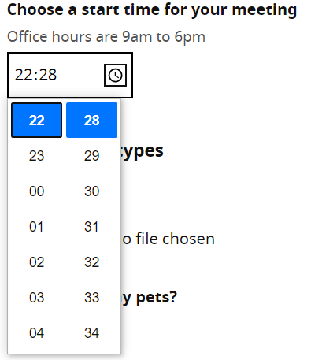

A minor issue was encountered when browsing with JAWS whereby the user attempts to close the time options using the ‘Esc’ key once a selection has been made, but the options are still present and audibly fed back to the user. This was disorientating for our screen reader analyst.

**Please note:** there are other accessible ways to interact with the feature and to make a selection; such as by using the arrow keys.

**Current code ref(s)**:

<input type="time" class="input-width-7" id="meeting-time" name="meeting-time" min="09:00" max="18:00">

**Screen reader comments:**

“With JAWS using Google Chrome and Microsoft Edge Chromium when I selected the ‘Show time picker’ button my focus was taken directly to the item. When I exited the item with the ‘Escape’ key my focus was taken back to the button. But when I attempted to select the button again my focus was not taken back to the picker. After further investigation I discovered that the list box items appeared directly after the button meaning that I could still locate the items, but this may not be clear to all users.

I further found that once the list box items were opened I was not able to collapse or hide the list boxes, which could make it time consuming for some screen reader users to locate the next item on the page.

Ensuring that I am taken to the list boxes on each occasion that I select the button will ensure I can locate the content; however, changing the button from show to ‘Hide’ once the button is selected will enable me to understand what is occurring and collapse the content when necessary.

With VoiceOver I was taken to the picker and was able to easily interact with all elements.

Browsing with TalkBack the picker behaved similarly to VoiceOver; however, I found it highly time consuming to locate the ‘Set’ button, although this is probably a device issue.

The picker is not located with NVDA.”

**Voice activation comments:**

“The choose start time box is not picked up by any Dragon commands. I was unable to access it was labelled by name or the click box, because of this is also does not pick up dictation. This means that the only way users will be able to access it is by using the Keyboard command of press tab to gain focus into it and then using keyboard commands of press XYZ to dictate into it. This would be more time-consuming for users to do and could confuse them as to why they can’t access it because they know they can access other edit fields on the page.”

**Voice activation comments:**“I could not access the time input using standard commands, so I had to use the command “Press tab” to tab to it. This is time-consuming especially when you have to tab through multiple elements on the page.”

**Solution:**You could consider using a standard text input to allow users to enter the date of arrival without encountering any issues.

### Skip links

In-page skip links are not conveyed to NVDA users.

**WCAG Reference:**

Usability

#### Issue ID: DAC-Skip-links

URL: <https://w3c-dev.studio24.dev/posts/post.html>

Screenshot:

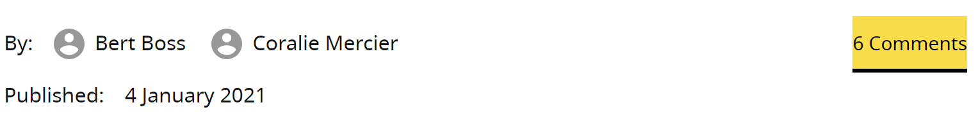

The functionality of the link is not conveyed to NVDA users and just announces as a link. Additionally, ‘6 comments’ may also be ambiguous for some users browsing out of context as the destination of the link is not clear.

This is a potential NVDA bug.

**Current code ref(s)**:

<a href="#comments" class="skip-to-comments txt-pluto">6 Comments</a>

**Screen reader comment:**

“I located a same page link that announced to me as ‘6 comments.’ With NVDA and TalkBack the announcing of same page links is not supported, meaning that the link appears as a standard link. This could mean that some screen reader users are not aware of what will occur prior to selecting the link and could become disorientated. Furthermore, with all software when situated out of context the link text does not indicate that the user will be moved to a different section of the page. Although focus moves as expected with all software for all skip links on the page providing a clear description within the link text, for example ‘Skip to comments section, six comments available’ would provide a clear instruction for all software both in and out of context. **I was not affected with JAWS or VoiceOver.**”

**Solution:**Consider amending the hypertext so that it describes its destination on the page.

**Suggestion:**‘Skip to 6 comments’

Alternatively, you could provide some hidden text to inform NVDA users that this link is in fact an in-page link.

**Example:**

**HTML**  
href="#comments" class="skip-to-comments txt-pluto">6 Comments**<span class="sr-only">in-page link</span>**</a>

**CSS**  
**.sr-only**

{

position: absolute; width: 1px; height: 1px; margin: -1px; padding: 0; overflow: hidden;

clip: rect(0,0,0,0); border: 0;

}

**Please note:** by doing this other users will hear this information twice; however, we feel this is a minor issue to encounter in comparison to the issue NVDA users experience, of not knowing the functionality of the link.

### Nested lists

Nested lists can sometimes be confusing for screen reader users.

**WCAG Reference:**

Usability

#### Issue ID: DAC-Nested-lists

URL: <https://w3c-dev.studio24.dev/posts/index.html>   
Consistent on <https://w3c-dev.studio24.dev/groups/index.html>

Screenshot:

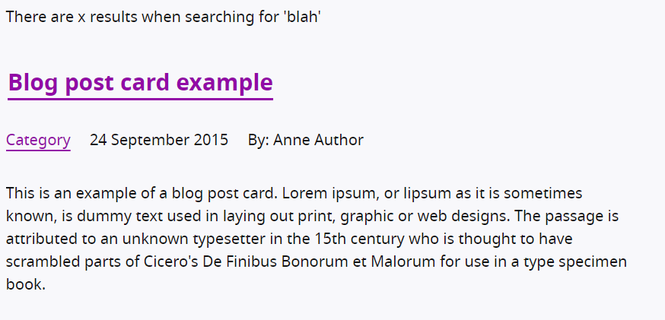

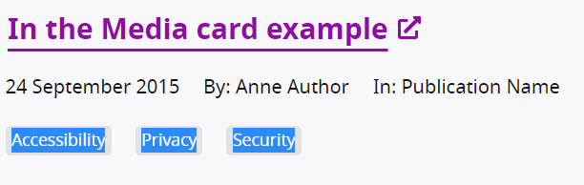

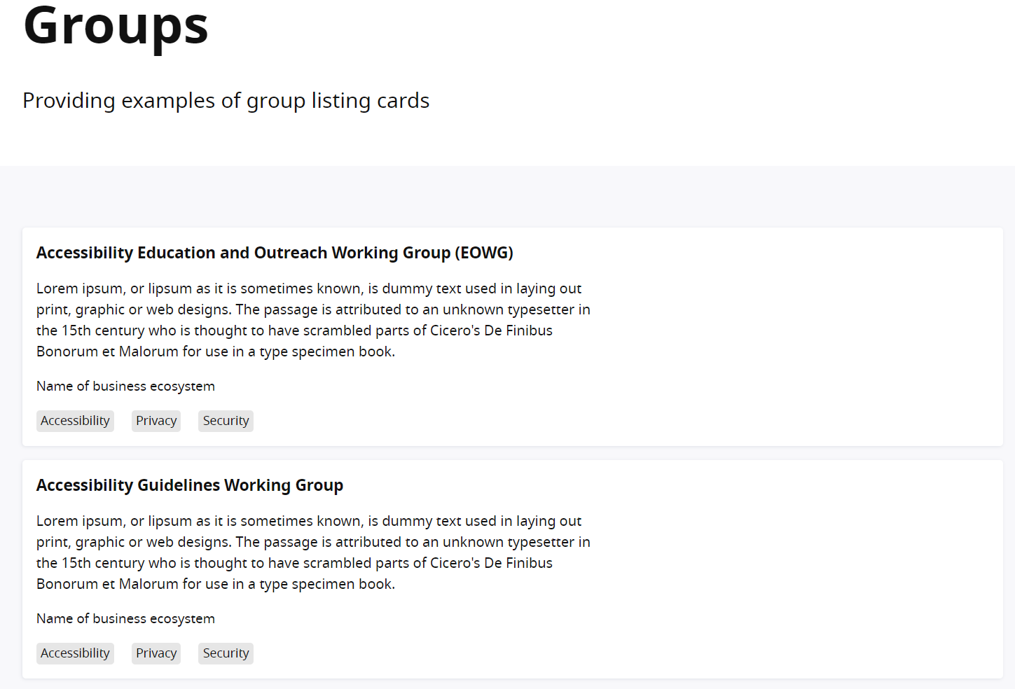

The list of items containing ‘Accessibility’ ‘Privacy’ and ‘Security’ is nested inside an unordered list used to present the results.

**Current code ref(s)**:

<ul class="clean-list post-list">

<li class="l-sidebar">

<ul class="clean-list">

<li>

<span class="tag">Accessibility</span>

</li>

<li>

<span class="tag">Privacy</span>

</li>

<li>

<span class="tag">Security</span>

</li>

</ul>

**Screen reader comment 1:**

“I found that the search results were contained in a list, with further nesting lists located near to the base of the main content. I found the lists more problematic to understand as there were multiple headings and links situated within the list which themselves provided structure to the page. As the headings and links do provide their own structure and allow me to clearly understand the content I would find it helpful if the overall list could be removed as it is not necessary functionality. This would also ensure that nesting lists become standard unordered lists and will provide a more efficient experience. **The issue is consistent with JAWS using Google Chrome and Microsoft Edge Chromium and NVDA. The issue does not occur with VoiceOver or TalkBack as the lists are not located.**”

**Issue consistent for similar functionality of the following pages:**

Events

Journey 1 step 4

<https://w3c-dev.studio24.dev/listing-events/index.html>

The W3C team

Journey 2 step 2

[The W3C team | W3C Redesign Prototypes (studio24.dev)](https://w3c-dev.studio24.dev/listing-people/index.html)

Members

Journey 2 step 3

<https://w3c-dev.studio24.dev/listing-members/index.html>

**Screen reader comment 2:**

“When I moved in context on the ‘Providing examples of group listing cards’ page, I found that a list of two items surrounded most of the main content. This was highly problematic for me as there were multiple headings, paragraphs and other nesting lists including a definition list situated within the overall list. I found it very challenging to identify where the first list item ended and the second began. I would find it highly beneficial if the overall list could be removed as this will enable me to understand the structure of the page more effectively. Please note that without the list the two headings would clearly introduce the sections of the page, with other lists appearing clearly to me. **The issue is present with JAWS using Google Chrome and Microsoft Edge Chromium, NVDA and VoiceOver. The lists are not located with TalkBack.**”

**Issue consistent for the following pages:**

The W3C team

Journey 2 step 2

[The W3C team | W3C Redesign Prototypes (studio24.dev)](https://w3c-dev.studio24.dev/listing-people/index.html)

**Solution:**Consider removing the unordered list markup from the results. Descriptive headings have been used to structure the results, which we feel would suffice.

**Example:  
~~<ul class="clean-list post-list">~~**

**~~<li class="l-sidebar">~~**

### Images

The image may blend into the background for some users.

**WCAG Reference:**

Usability

#### Issue ID: DAC-Images

URL: <https://w3c-dev.studio24.dev/listing-people/index.html>

Screenshot:



Our low vision analyst with a specific eye condition felt that images would be beneficial with an outline border, so they are presented in a way which is easier to decipher.

**Current code ref(s)**:

<img alt="" src="https://www.w3.org/2006/05/u/1682ihk1hqqo-sm.jpg" loading="lazy">

**Screen reader comments:**

“As I have a visual impairment which includes Nystagmus (Dancing Eyes) I find that if images don’t have a border around them my visual focus is often affected. Sometimes images/ photos have a similar colour to the background which makes the image disappear into the background. Even just a black 1px outline would lift the image off the page and make navigation easier on the eyes of the person viewing the page, in this case, myself.”

**Solution:**

Consider adding a border around the image to aid users with specific eye conditions.

### Carousel

The carousel was accessible with some minor accessibility issues encountered by our screen reader analyst.

**WCAG Reference:**

Usability

#### Issue ID: DAC-Carousel

URL: <https://w3c-dev.studio24.dev/business/index.html>

Screenshot:



The carousel was now accessible and understandable. It was only our screen reader analyst that encountered some small usability issues.

**Current code ref(s)**:

<section aria-labelledby="slider-title" aria-roledescription="carousel" class="js-slider">

<ul class="clean-list" role="presentation" tabindex="0" aria-label="carousel content" style="transform: translateX(0px);">

<li class="js-current" style="left: 0px;">

**Screen reader comments:**

“I found that I was able to use the carousel as the feature has become far easier to use. However, there are some issues that do still remain ranging from minor to potentially problematic.

**JAWS:** using Google Chrome and Microsoft Edge Chromium I found that the slide was contained in a list of a single item. This list was not necessary as due to the amount of content in each slide it made it problematic to identify where the list ended. Removing the list would provide me with a more efficient experience. The list was not located with NVDA or VoiceOver.

While situated in context with JAWS I located a group which announced the slide number for example ‘2 of 3.’ However, the phrase ‘Slide’ was not included in the group description meaning it was not immediately obvious what the numbers related to.

Adding the phrase ‘Slide’ will ensure that I am able to easily understand the content.

**NVDA:** I did not locate the group or the number of the slide. I was only able to receive an indication of ‘Carousel slide’; however, this did advise me that I had entered the slide, but not the number of the slide.

**VoiceOver:** I was not given an indication of where the slide began or ended. I was not advised of the group or slide number as these were not located and when swiping in context would not have been aware that I was entering a slide or viewing a carousel until I reached the carousel control buttons.

With all software when I selected the ‘Next’ and ‘Previous’ slide button my focus was taken to the top of the slide as expected and worked well.

The carousel was easy to use with JAWS with the exception of the two minor issues. NVDA was somewhat more challenging due to how the beginning of the slide announced. VoiceOver was far more challenging for me to use, as I could not identify where each slide began and ended.”

**Solution:**No solution required. Consider implementing the small changes identified by our screen reader user if possible.

### Styling

The styling of the section may blend into the background for some users with a vision impairment.

**WCAG Reference:**

Usability

#### Issue ID: DAC-Styling

URL: <https://w3c-dev.studio24.dev/listing-events/event.html>

Screenshot:

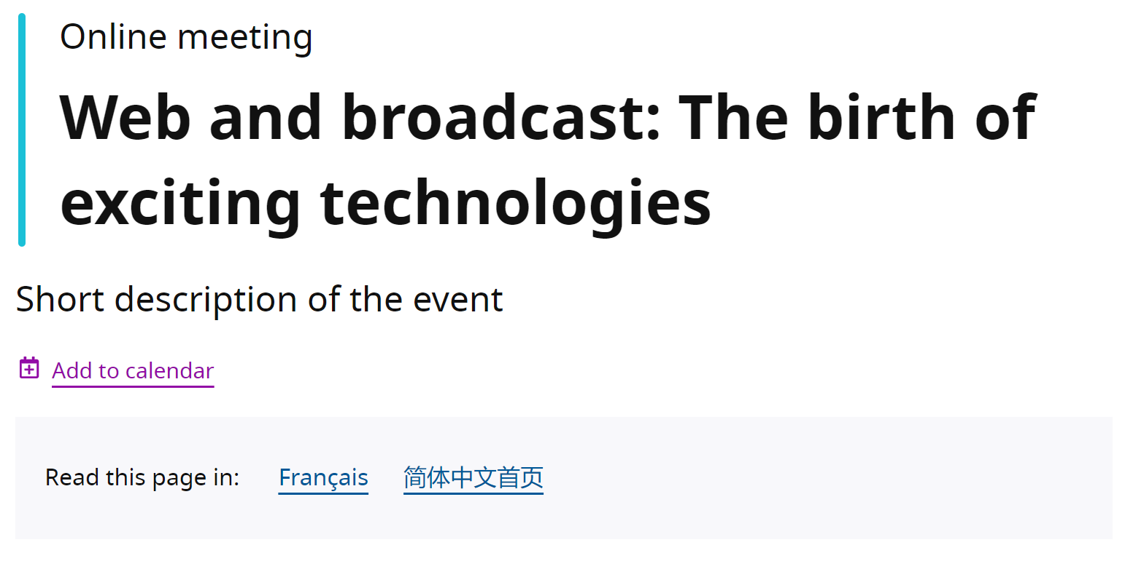

Although this did not pose an accessibility barrier, our low vision analyst felt that the section used could be better displayed, as it is a section of a page.

**Current code ref(s)**:

<section class="l-box l-box--no-border translations">

**Low vision comments:**

“The grey background is not of a substantial enough contrast between the white background to be able to see that the grey container is sitting on the white background.”

**Solution:**

You could consider a darker shade of grey so that the section is more dominant for some low vision users who may find this difficult to see; however, you must also ensure that the hypertext within this section then passes colour contrast against the background colour.

### Link

The link has no distinguishable visual cue to inform the user that they are on the current page.

**WCAG Reference:**

Usability

#### Issue ID: DAC-Link

URL: [https://w3c-dev.studio24.dev/groups/group-details.html#](https://w3c-dev.studio24.dev/groups/group-details.html)

Screenshot:

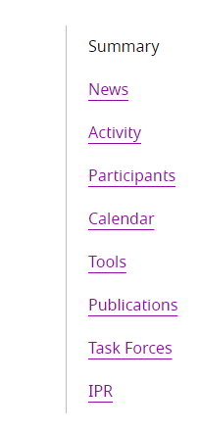

**When receiving focus**

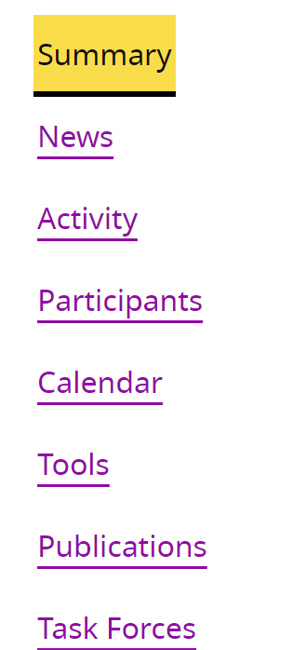

Although it is programmatically determined that the user is on the current page (summary), visually this is not the case, yet the link still receives focus but does not activate when selected.

**Current code ref(s)**:

<a href="#" aria-current="true">Summary</a>

**Solution:**

Consider adding clearer indication that this is the current page, other than using the appearance of standard text.

# End of Report

## Appendix I

Priority items to be tested:

* [Form elements](https://w3c-dev.studio24.dev/forms.html) (these aren’t linked to a back-end, but please check the front-end function of these fields. For example, we think there might be issues with the destination field functionality)
* [Listing page: posts (blog, news, press release, in the media)](https://w3c-dev.studio24.dev/posts/index.html)
* [Single post](https://w3c-dev.studio24.dev/posts/post.html)
* [Listing page: events](https://w3c-dev.studio24.dev/listing-events/index.html)
* [Single event post](https://w3c-dev.studio24.dev/listing-events/event.html)
* Retest the carousel on the Business Ecosystem page at <https://w3c-dev.studio24.dev/business/index.html>

Secondary priority (in order of priority)

* [Listing page: groups](https://w3c-dev.studio24.dev/groups/index.html) (this is a card example, based on other card components, so can go right at the bottom of the priority list)
* [Group details illustrating secondary (group) navigation](https://w3c-dev.studio24.dev/groups/group-details.html) (this component is a left-hand navigation on wide screens, which goes to a drop-down navigation on mobile screens)
* [Listing page: people](https://w3c-dev.studio24.dev/listing-people/index.html)
* [Listing page: members](https://w3c-dev.studio24.dev/listing-members/index.html)
* [Form error messages](https://w3c-dev.studio24.dev/form-errors.html)
* [Archive banner](https://w3c-dev.studio24.dev/archive-banner.html)

## Appendix II

### Classification of Accessibility Issues

The following scoring system was used to indicate the status of the sites with regards to each W3C WAI checkpoint up to and including Level AAA:

|  |  |
| --- | --- |
| **Status** | **Description** |
| **Pass (P)** | The site meets the requirements of the checkpoint. |
| **Fail (L) Low Priority** | The site almost meets the requirements of the checkpoint. Only a small number of minor problems were identified. The site fails to meet the requirements against AAA criteria measured against WCAG 2.1 |
| **Fail (M) Medium Priority** | The site fails to meet the requirements against AA criteria measured against WCAG 2.1 |
| **Fail (H) High Priority** | The site fails to meet the requirements against A criteria measured against WCAG 2.1 and more severe accessibility issues were identified. |
| **Not Applicable (N/A)** | No content was found on the site to which the checkpoint would relate. |

|  |
| --- |
| **Principle 1: Perceivable – Information and users interface components must be presentable to users in ways they can perceive.** |
| **Non-text Content:**  [1.1.1](http://www.w3.org/TR/WCAG20/#text-equiv-all) All [non-text content](http://www.w3.org/TR/2008/REC-WCAG20-20081211/#non-text-contentdef) that is presented to the user has a [text alternative](http://www.w3.org/TR/2008/REC-WCAG20-20081211/#text-altdef) that serves the equivalent purpose.  (Level A) | **Pass (P)** |
| **Audio-only and Video-only (Pre-recorded):**  [1.2.1](http://www.w3.org/TR/WCAG20/#media-equiv-av-only-alt) For [pre-recorded](http://www.w3.org/TR/2008/REC-WCAG20-20081211/#prerecordeddef)  [audio-only](http://www.w3.org/TR/2008/REC-WCAG20-20081211/#audio-onlydef) and pre-recorded [video-only](http://www.w3.org/TR/2008/REC-WCAG20-20081211/#video-onlydef) media, the following are true, except when the audio or video is a [media alternative for text](http://www.w3.org/TR/2008/REC-WCAG20-20081211/#multimedia-alt-textdef) and is clearly labelled as such:  [Understanding Success Criterion 1.2.1](http://www.w3.org/TR/UNDERSTANDING-WCAG20/media-equiv-av-only-alt.html)   * **Pre-recorded Audio-only:** An [alternative for time-based media](http://www.w3.org/TR/2008/REC-WCAG20-20081211/#alt-time-based-mediadef) is provided that presents equivalent information for pre-recorded audio-only content. * **Pre-recorded Video-only:** Either an alternative for time-based media or an audio track is provided that presents equivalent information for pre-recorded video-only content.   (Level A) | **N/A** |
| **Captions (Pre-recorded):**  [1.2.2](http://www.w3.org/TR/WCAG20/#media-equiv-captions) [Captions](http://www.w3.org/TR/2008/REC-WCAG20-20081211/#captionsdef) are provided for all [pre-recorded](http://www.w3.org/TR/2008/REC-WCAG20-20081211/#prerecordeddef)  [audio](http://www.w3.org/TR/2008/REC-WCAG20-20081211/#audiodef) content in [synchronized media](http://www.w3.org/TR/2008/REC-WCAG20-20081211/#synchronizedmediadef), except when the media is a [media alternative for text](http://www.w3.org/TR/2008/REC-WCAG20-20081211/#multimedia-alt-textdef) and is clearly labelled as such.  (Level A) | **N/A** |
| **Audio Description or Media Alternative (Pre-recorded):**  [1.2.3](http://www.w3.org/TR/WCAG20/#media-equiv-audio-desc) An [alternative for time-based media](http://www.w3.org/TR/2008/REC-WCAG20-20081211/#alt-time-based-mediadef) or [audio description](http://www.w3.org/TR/2008/REC-WCAG20-20081211/#audiodescdef) of the [pre-recorded](http://www.w3.org/TR/2008/REC-WCAG20-20081211/#prerecordeddef)  [video](http://www.w3.org/TR/2008/REC-WCAG20-20081211/#videodef) content is provided for [synchronized media](http://www.w3.org/TR/2008/REC-WCAG20-20081211/#synchronizedmediadef), except when the media is a [media alternative for text](http://www.w3.org/TR/2008/REC-WCAG20-20081211/#multimedia-alt-textdef) and is clearly labelled as such.  (Level A) | **N/A** |
| **Captions (Live):**  [1.2.4](http://www.w3.org/TR/WCAG20/#media-equiv-real-time-captions) [Captions](http://www.w3.org/TR/2008/REC-WCAG20-20081211/#captionsdef) are provided for all [live](http://www.w3.org/TR/2008/REC-WCAG20-20081211/#livedef) [audio](http://www.w3.org/TR/2008/REC-WCAG20-20081211/#audiodef) content in [synchronized media](http://www.w3.org/TR/2008/REC-WCAG20-20081211/#synchronizedmediadef).  (Level AA) | **N/A** |
| **Audio Description (Pre-recorded):**  [1.2.5](http://www.w3.org/TR/WCAG20/#media-equiv-audio-desc-only) [Audio description](http://www.w3.org/TR/2008/REC-WCAG20-20081211/#audiodescdef) is provided for all [pre-recorded](http://www.w3.org/TR/2008/REC-WCAG20-20081211/#prerecordeddef)  [video](http://www.w3.org/TR/2008/REC-WCAG20-20081211/#videodef) content in [synchronized media](http://www.w3.org/TR/2008/REC-WCAG20-20081211/#synchronizedmediadef).  (Level AA) | **N/A** |
| **Sign Language (Pre-recorded):**  [1.2.6](http://www.w3.org/TR/WCAG20/#media-equiv-sign) [Sign language interpretation](http://www.w3.org/TR/2008/REC-WCAG20-20081211/#sign-languageinterpdef) is provided for all [pre-recorded](http://www.w3.org/TR/2008/REC-WCAG20-20081211/#prerecordeddef)  [audio](http://www.w3.org/TR/2008/REC-WCAG20-20081211/#audiodef) content in [synchronized media](http://www.w3.org/TR/2008/REC-WCAG20-20081211/#synchronizedmediadef).  (Level AAA) | **N/A** |
| **Extended Audio Description (Pre-recorded):**  [1.2.7](http://www.w3.org/TR/WCAG20/#media-equiv-extended-ad)Where pauses in foreground audio are insufficient to allow [audio descriptions](http://www.w3.org/TR/2008/REC-WCAG20-20081211/#audiodescdef) to convey the sense of the video, [extended audio description](http://www.w3.org/TR/2008/REC-WCAG20-20081211/#extended-addef) is provided for all [pre-recorded](http://www.w3.org/TR/2008/REC-WCAG20-20081211/#prerecordeddef)  [video](http://www.w3.org/TR/2008/REC-WCAG20-20081211/#videodef) content in [synchronized media](http://www.w3.org/TR/2008/REC-WCAG20-20081211/#synchronizedmediadef).  (Level AAA) | **N/A** |
| **Media Alternative (Pre-recorded):**  [1.2.8](http://www.w3.org/TR/WCAG20/#media-equiv-text-doc)An [alternative for time-based media](http://www.w3.org/TR/2008/REC-WCAG20-20081211/#alt-time-based-mediadef) is provided for all [pre-recorded](http://www.w3.org/TR/2008/REC-WCAG20-20081211/#prerecordeddef)  [synchronized media](http://www.w3.org/TR/2008/REC-WCAG20-20081211/#synchronizedmediadef) and for all pre-recorded [video-only](http://www.w3.org/TR/2008/REC-WCAG20-20081211/#video-onlydef) media.  (Level AAA) | **N/A** |
| **Audio-only (Live):**  [1.2.9](http://www.w3.org/TR/WCAG20/#media-equiv-live-audio-only)An [alternative for time-based media](http://www.w3.org/TR/2008/REC-WCAG20-20081211/#alt-time-based-mediadef) that presents equivalent information for [live](http://www.w3.org/TR/2008/REC-WCAG20-20081211/#livedef) [audio-only](http://www.w3.org/TR/2008/REC-WCAG20-20081211/#audio-onlydef) content is provided.  (Level AAA) | **N/A** |
| **Info and Relationships:**  [1.3.1](http://www.w3.org/TR/WCAG20/#content-structure-separation-programmatic) Information, [structure](http://www.w3.org/TR/2008/REC-WCAG20-20081211/#structuredef), and [relationships](http://www.w3.org/TR/2008/REC-WCAG20-20081211/#relationshipsdef) conveyed through [presentation](http://www.w3.org/TR/2008/REC-WCAG20-20081211/#presentationdef) can be [programmatically determined](http://www.w3.org/TR/2008/REC-WCAG20-20081211/#programmaticallydetermineddef) or are available in text.  **(Level A)** | **Fail (H)** |
| **Meaningful Sequence:**  [1.3.2](http://www.w3.org/TR/WCAG20/#content-structure-separation-sequence) When the sequence in which content is presented affects it’s meaning, a [correct reading sequence](http://www.w3.org/TR/2008/REC-WCAG20-20081211/#correct-reading-sequencedef) can be [programmatically determined](http://www.w3.org/TR/2008/REC-WCAG20-20081211/#programmaticallydetermineddef).  (Level A) | **Pass (A)** |
| **Sensory Characteristics:**  [1.3.3](http://www.w3.org/TR/WCAG20/#content-structure-separation-understanding) Instructions provided for understanding and operating content do not rely solely on sensory characteristics of components such as shape, size, visual location, orientation, or sound.  (Level A) | **N/A** |

|  |  |
| --- | --- |
| **Orientation: (WCAG 2.1)**  [1.3.4](https://www.w3.org/WAI/WCAG21/quickref/#orientation) Content does not restrict its view and operation to a single display orientation, such as portrait or landscape, unless a specific display orientation is essential.  Note: Examples where a particular display orientation may be essential are a bank check, a piano application, slides for a projector or television, or virtual reality content where binary display orientation is not applicable.  (Level AA) | **Pass (AA)** |
| **Identify Input Purpose: (WCAG 2.1)**  [1.3.5](https://www.w3.org/WAI/WCAG21/quickref/#identify-input-purpose) The purpose of each input field collecting information about the user can be [programmatically determined](https://www.w3.org/TR/WCAG21/#dfn-programmatically-determinable) when :   * The input field serves a purpose identified in the [Input Purposes for User Interface Components section](https://www.w3.org/TR/WCAG21/#input-purposes); and * The content is implemented using technologies with support for identifying the expected meaning for form input data.   (Level AA) | **N/A** |
| **Identify Purpose: (WCAG 2.1)**  [1.3.6](https://www.w3.org/WAI/WCAG21/quickref/#identify-purpose)In content implemented using mark-up languages, the purpose of User Interface Components, icons, and regions can be programmatically determined.  (Level AAA) | **N/A** |
| **Use of Colour:**  [1.4.1](http://www.w3.org/TR/WCAG20/#visual-audio-contrast-without-color) Colour is not used as the only visual means of conveying information, indicating an action, prompting a response, or distinguishing a visual element.  (Level A) | **Pass (A)** |
| **Audio Control:**  [1.4.2](http://www.w3.org/TR/WCAG20/#visual-audio-contrast-dis-audio)If any audio on a Web page plays automatically for more than 3 seconds, either a [mechanism](http://www.w3.org/TR/2008/REC-WCAG20-20081211/#mechanismdef) is available to pause or stop the audio, or a mechanism is available to control audio volume independently from the overall system volume level.  (Level A) | **N/A** |

|  |  |
| --- | --- |
| **Contrast (Minimum):**  [1.4.3](http://www.w3.org/TR/WCAG20/#visual-audio-contrast-contrast) The visual presentation of [text](http://www.w3.org/TR/2008/REC-WCAG20-20081211/#textdef) and [images of text](http://www.w3.org/TR/2008/REC-WCAG20-20081211/#images-of-textdef) has a [contrast ratio](http://www.w3.org/TR/2008/REC-WCAG20-20081211/#contrast-ratiodef) of at least 4.5:1, except for the following:   * **Large Text:** [Large-scale](http://www.w3.org/TR/2008/REC-WCAG20-20081211/#larger-scaledef) text and images of large-scale text have a contrast ratio of at least 3:1; * **Incidental:** Text or images of text that are part of an inactive [user interface component](http://www.w3.org/TR/2008/REC-WCAG20-20081211/#user-interface-componentdef), that are [pure decoration](http://www.w3.org/TR/2008/REC-WCAG20-20081211/#puredecdef), that are not visible to anyone, or that are part of a picture that contains significant other visual content, have no contrast requirement. * **Logotypes:** Text that is part of a logo or brand name has no minimum contrast requirement.   (Level AA) | **Pass (AA)** |
| **Resize text:**  [1.4.4](http://www.w3.org/TR/WCAG20/#visual-audio-contrast-scale) Except for [captions](http://www.w3.org/TR/2008/REC-WCAG20-20081211/#captionsdef) and [images of text](http://www.w3.org/TR/2008/REC-WCAG20-20081211/#images-of-textdef), [text](http://www.w3.org/TR/2008/REC-WCAG20-20081211/#textdef) can be resized without [assistive technology](http://www.w3.org/TR/2008/REC-WCAG20-20081211/#atdef) up to 200 percent without loss of content or functionality.  (Level AA) | **Fail (M)** |
| **Images of Text:**  [1.4.5](http://www.w3.org/TR/WCAG20/#visual-audio-contrast-text-presentation)If the technologies being used can achieve the visual presentation, [text](http://www.w3.org/TR/2008/REC-WCAG20-20081211/#textdef) is used to convey information rather than [images of text](http://www.w3.org/TR/2008/REC-WCAG20-20081211/#images-of-textdef) except for the following:  [Understanding Success Criterion 1.4.5](http://www.w3.org/TR/UNDERSTANDING-WCAG20/visual-audio-contrast-text-presentation.html)   * **Customizable:** The image of text can be [visually customized](http://www.w3.org/TR/2008/REC-WCAG20-20081211/#visually-customizeddef) to the user's requirements; * **Essential:** A particular presentation of text is [essential](http://www.w3.org/TR/2008/REC-WCAG20-20081211/#essentialdef) to the information being conveyed.   **Note**: Logotypes (text that is part of a logo or brand name) are considered essential.  (Level AA) | **N/A** |

|  |  |
| --- | --- |
| **Contrast (Enhanced):**  [1.4.6](http://www.w3.org/TR/WCAG20/#visual-audio-contrast7) The visual presentation of [text](http://www.w3.org/TR/2008/REC-WCAG20-20081211/#textdef) and [images of text](http://www.w3.org/TR/2008/REC-WCAG20-20081211/#images-of-textdef) has a [contrast ratio](http://www.w3.org/TR/2008/REC-WCAG20-20081211/#contrast-ratiodef) of at least 7:1, except for the following:   * **Large Text:** [Large-scale](http://www.w3.org/TR/2008/REC-WCAG20-20081211/#larger-scaledef) text and images of large-scale text have a contrast ratio of at least 4.5:1; * **Incidental:** Text or images of text that are part of an inactive [user interface component](http://www.w3.org/TR/2008/REC-WCAG20-20081211/#user-interface-componentdef), that are [pure decoration](http://www.w3.org/TR/2008/REC-WCAG20-20081211/#puredecdef), that are not visible to anyone, or that are part of a picture that contains significant other visual content, have no contrast requirement. * **Logotypes:** Text that is part of a logo or brand name has no minimum contrast requirement.   (Level AAA) | **N/A** |
| **Low or No Background Audio:**  [1.4.7](http://www.w3.org/TR/WCAG20/#visual-audio-contrast-noaudio)For [pre-recorded](http://www.w3.org/TR/2008/REC-WCAG20-20081211/#prerecordeddef)  [audio-only](http://www.w3.org/TR/2008/REC-WCAG20-20081211/#audio-onlydef) content that (1) contains primarily speech in the foreground, (2) is not an audio [CAPTCHA](http://www.w3.org/TR/2008/REC-WCAG20-20081211/#CAPTCHAdef) or audio logo, and (3) is not vocalization intended to be primarily musical expression such as singing or rapping, at least one of the following is true:  [Understanding Success Criterion 1.4.7](http://www.w3.org/TR/UNDERSTANDING-WCAG20/visual-audio-contrast-noaudio.html)   * **No Background:** The audio does not contain background sounds. * **Turn Off:** The background sounds can be turned off. * **20 dB:** The background sounds are at least 20 decibels lower than the foreground speech content, with the exception of occasional sounds that last for only one or two seconds.   Note*:* Per the definition of "decibel," background sound that meets this requirement will be approximately four times quieter than the foreground speech content.  (Level AAA) | **N/A** |

|  |  |
| --- | --- |
| **Visual Presentation:**  [1.4.8](http://www.w3.org/TR/WCAG20/#visual-audio-contrast-visual-presentation)For the visual presentation of [blocks of text](http://www.w3.org/TR/2008/REC-WCAG20-20081211/#blockstextdef), a [mechanism](http://www.w3.org/TR/2008/REC-WCAG20-20081211/#mechanismdef) is available to achieve the following:  [Understanding Success Criterion 1.4.8](http://www.w3.org/TR/UNDERSTANDING-WCAG20/visual-audio-contrast-visual-presentation.html)   1. Foreground and background colours can be selected by the user. 2. Width is no more than 80 characters or glyphs (40 if CJK). 3. Text is not justified (aligned to both the left and the right margins). 4. Line spacing (leading) is at least space-and-a-half within paragraphs, and paragraph spacing is at least 1.5 times larger than the line spacing. 5. Text can be resized without assistive technology up to 200 percent in a way that does not require the user to scroll horizontally to read a line of text [on a full-screen window](http://www.w3.org/TR/2008/REC-WCAG20-20081211/#fullscreenwindowdef).   (Level AAA) | **N/A** |
| **Images of Text (No Exception):**  [1.4.9](http://www.w3.org/TR/WCAG20/#visual-audio-contrast-text-images)[Images of text](http://www.w3.org/TR/2008/REC-WCAG20-20081211/#images-of-textdef) are only used for [pure decoration](http://www.w3.org/TR/2008/REC-WCAG20-20081211/#puredecdef) or where a particular presentation of [text](http://www.w3.org/TR/2008/REC-WCAG20-20081211/#textdef) is [essential](http://www.w3.org/TR/2008/REC-WCAG20-20081211/#essentialdef) to the information being conveyed.  Note:Logotypes (text that is part of a logo or brand name) are considered essential.  (Level AAA) | **N/A** |
| **Reflow: (WCAG 2.1)**  [1.4.10](https://www.w3.org/WAI/WCAG21/quickref/#reflow)Content can be presented without loss of information or functionality, and without requiring scrolling in two dimensions for :   * Vertical scrolling content at a width equivalent to 320 [CSS pixels](https://www.w3.org/TR/WCAG21/#dfn-css-pixels); * Horizontal scrolling content at a height equivalent to 256 [CSS pixels](https://www.w3.org/TR/WCAG21/#dfn-css-pixels).   Except for parts of the content which require two-dimensional layout for usage or meaning.  Note: 320 CSS pixels is equivalent to a starting viewport width of 1280 CSS pixels wide at 400% zoom. For web content which are designed to scroll horizontally (e.g. with vertical text), the 256 CSS pixels is equivalent to a starting viewport height of 1024px at 400% zoom.  Note: Examples of content which require two-dimensional layout are images, maps, diagrams, video, games, presentations, data tables, and interfaces where it is necessary to keep toolbars in view while manipulating content.  (Level AA) | **Fail (M)** |

|  |  |
| --- | --- |
| **Non-text Contrast: (WCAG 2.1)**  [1.4.11](https://www.w3.org/WAI/WCAG21/quickref/#non-text-contrast)The visual [presentation](https://www.w3.org/TR/WCAG21/#dfn-presentation) of the following have a [contrast ratio](https://www.w3.org/TR/WCAG21/#dfn-contrast-ratio) of at least 3:1 against adjacent color(s):   * **User Interface Components** Visual information required to identify [user interface components](https://www.w3.org/TR/WCAG21/#dfn-user-interface-components) and [states](https://www.w3.org/TR/WCAG21/#dfn-states), except for inactive components or where the appearance of the component is determined by the user agent and not modified by the author; * **Graphical Objects** Parts of graphics required to understand the content, except when a particular presentation of graphics is [essential](https://www.w3.org/TR/WCAG21/#dfn-essential) to the information being conveyed.   (Level AA) | **Pass (AA)** |
| **Text Spacing: (WCAG 2.1)**  [1.4.12](https://www.w3.org/WAI/WCAG21/quickref/#text-spacing)presentation of graphics is [essential](https://www.w3.org/TR/WCAG21/#dfn-essential) to the information being conveyed.  In content implemented using mark-up languages that support the following [text](https://www.w3.org/TR/WCAG21/#dfn-text) [style properties](https://www.w3.org/TR/WCAG21/#dfn-style-properties), no loss of content or functionality occurs by setting all of the following and by changing no other style property:   * Line height (line spacing) to at least 1.5 times the font size; * Spacing following paragraphs to at least 2 times the font size; * Letter spacing (tracking) to at least 0.12 times the font size; * Word spacing to at least 0.16 times the font size.   Exception: Human languages and scripts that do not make use of one or more of these text style properties in written text can conform using only the properties that exist for that combination of language and script.  (Level AA) | **Pass (AA)** |

|  |  |
| --- | --- |
| **Content on Hover or Focus: (WCAG 2.1)**  [1.4.13](https://www.w3.org/WAI/WCAG21/quickref/#content-on-hover-or-focus)Where receiving and then removing pointer hover or keyboard focus triggers additional content to become visible and then hidden, the following are true:   * **Dismissible** A [mechanism](https://www.w3.org/TR/WCAG21/#dfn-mechanism) is available to dismiss the additional content without moving pointer hover or keyboard focus, unless the additional content communicates an [input error](https://www.w3.org/TR/WCAG21/#dfn-input-error) or does not obscure or replace other content; * **Hoverable** If pointer hover can trigger the additional content, then the pointer can be moved over the additional content without the additional content disappearing; * **Persistent** The additional content remains visible until the hover or focus trigger is removed, the user dismisses it, or its information is no longer valid.   Exception: The visual presentation of the additional content is controlled by the user agent and is not modified by the author.  Note: Examples of additional content controlled by the user agent include browser tooltips created through use of the HTML [title attribute](https://www.w3.org/TR/html/dom.html#the-title-attribute).  Note: Custom tooltips, sub-menus, and other nonmodal popups that display on hover and focus are examples of additional content covered by this criterion.  (Level AA) | **N/A** |

|  |
| --- |
| **Principle 2: Operable – User interface components and navigation must be operable.** |
| **Keyboard:**  [2.1.1](http://www.w3.org/TR/WCAG20/#keyboard-operation-keyboard-operable) All [functionality](http://www.w3.org/TR/2008/REC-WCAG20-20081211/#functiondef) of the content is operable through a [keyboard interface](http://www.w3.org/TR/2008/REC-WCAG20-20081211/#keybrd-interfacedef) without requiring specific timings for individual keystrokes, except where the underlying function requires input that depends on the path of the user's movement and not just the endpoints.  Note: This exception relates to the underlying function, not the input technique. For example, if using handwriting to enter text, the input technique (handwriting) requires path-dependent input but the underlying function (text input) does not.  Note: This does not forbid and should not discourage providing mouse input or other input methods in addition to keyboard operation.  (Level A) | **Pass (A)** |
| **No Keyboard Trap:**  [2.1.2](http://www.w3.org/TR/WCAG20/#keyboard-operation-trapping) If keyboard focus can be moved to a component of the page using a [keyboard interface](http://www.w3.org/TR/2008/REC-WCAG20-20081211/#keybrd-interfacedef), then focus can be moved away from that component using only a keyboard interface, and, if it requires more than unmodified arrow or tab keys or other standard exit methods, the user is advised of the method for moving focus away.  Note: Since any content that does not meet this success criterion can interfere with a user's ability to use the whole page, all content on the Web page (whether it is used to meet other success criteria or not) must meet this success criterion.  (Level A) | **Pass (A)** |
| **Keyboard (No Exception):**  [2.1.3](http://www.w3.org/TR/WCAG20/#keyboard-operation-all-funcs) All [functionality](http://www.w3.org/TR/2008/REC-WCAG20-20081211/#functiondef) of the content is operable through a [keyboard interface](http://www.w3.org/TR/2008/REC-WCAG20-20081211/#keybrd-interfacedef) without requiring specific timings for individual keystrokes.  (Level AAA) | **Pass (AAA)** |

|  |  |
| --- | --- |
| **Character Key Shortcuts: (WCAG 2.1)**  [2.1.4](https://www.w3.org/WAI/WCAG21/quickref/#character-key-shortcuts) If a [keyboard shortcut](https://www.w3.org/TR/WCAG21/#dfn-keyboard-shortcuts) is implemented in content using only letter (including upper- and lower-case letters), punctuation, number, or symbol characters, then at least one of the following is true:   * **Turn off:** A [mechanism](https://www.w3.org/TR/WCAG21/#dfn-mechanism) is available to turn the shortcut off; * **Remap:** A mechanism is available to remap the shortcut to use one or more non-printable keyboard characters (e.g. Ctrl, Alt, etc); * **Active only on focus:** The keyboard shortcut for a [user interface component](https://www.w3.org/TR/WCAG21/#dfn-user-interface-components) is only active when that component has focus.   (Level A) | **N/A** |
| **Timing Adjustable:**  [2.2.1](http://www.w3.org/TR/WCAG20/#time-limits-required-behaviors) For each time limit that is set by the content, at least one of the following is true:   * **Turn off:** The user is allowed to turn off the time limit before encountering it; * **Adjust:** The user is allowed to adjust the time limit before encountering it over a wide range that is at least ten times the length of the default setting; * **Extend:** The user is warned before time expires and given at least 20 seconds to extend the time limit with a simple action (for example, "press the space bar"), and the user is allowed to extend the time limit at least ten times; * **Real-time Exception:** The time limit is a required part of a real-time event (for example, an auction), and no alternative to the time limit is possible; * **Essential Exception:** The time limit is [essential](http://www.w3.org/TR/2008/REC-WCAG20-20081211/#essentialdef) and extending it would invalidate the activity; * **20 Hour Exception:** The time limit is longer than 20 hours.   Note: This success criterion helps ensure that users can complete tasks without unexpected changes in content or context that are a result of a time limit. This success criterion should be considered in conjunction with [Success Criterion 3.2.1](http://www.w3.org/TR/2008/REC-WCAG20-20081211/#consistent-behavior-receive-focus), which puts limits on changes of content or context as a result of user action.  (Level A) | **N/A** |

|  |  |
| --- | --- |
| **Pause, Stop, Hide:**  [2.2.2](http://www.w3.org/TR/WCAG20/#time-limits-pause) For moving, [blinking](http://www.w3.org/TR/2008/REC-WCAG20-20081211/#blinksdef), scrolling, or auto-updating information, all of the following are true:  [Understanding Success Criterion 2.2.2](http://www.w3.org/TR/UNDERSTANDING-WCAG20/time-limits-pause.html)   * **Moving, blinking, scrolling**: For any moving, blinking or scrolling information that (1) starts automatically, (2) lasts more than five seconds, and (3) is presented in parallel with other content, there is a mechanism for the user to [pause](http://www.w3.org/TR/2008/REC-WCAG20-20081211/#pauseddef), stop, or hide it unless the movement, blinking, or scrolling is part of an activity where it is [essential](http://www.w3.org/TR/2008/REC-WCAG20-20081211/#essentialdef); and * **Auto-updating:** For any auto-updating information that (1) starts automatically and (2) is presented in parallel with other content, there is a mechanism for the user to pause, stop, or hide it or to control the frequency of the update unless the auto-updating is part of an activity where it is essential.   Note: For requirements related to flickering or flashing content, refer to [Guideline 2.3](http://www.w3.org/WAI/WCAG20/quickref/#seizure).  Note: Since any content that does not meet this success criterion can interfere with a user's ability to use the whole page, all content on the Web page (whether it is used to meet other success criteria or not) must meet this success criterion.  Note: Content that is updated periodically by software or that is streamed to the user agent is not required to preserve or present information that is generated or received between the initiation of the pause and resuming presentation, as this may not be technically possible, and in many situations could be misleading to do so.  Note: An animation that occurs as part of a preload phase or similar situation can be considered essential if interaction cannot occur during that phase for all users and if not indicating progress could confuse users or cause them to think that content was frozen or broken.  (Level A) | **N/A** |
| **No Timing:**  [2.2.3](http://www.w3.org/TR/WCAG20/#time-limits-no-exceptions) Timing is not an [essential](http://www.w3.org/TR/2008/REC-WCAG20-20081211/#essentialdef) part of the event or activity presented by the content, except for non-interactive [synchronized media](http://www.w3.org/TR/2008/REC-WCAG20-20081211/#synchronizedmediadef) and [real-time events](http://www.w3.org/TR/2008/REC-WCAG20-20081211/#real-time-eventsdef).  (Level AAA) | **N/A** |

|  |  |
| --- | --- |
| **Interruptions:**  [2.2.4](http://www.w3.org/TR/WCAG20/#time-limits-postponed) Interruptions can be postponed or suppressed by the user, except interruptions involving an [emergency](http://www.w3.org/TR/2008/REC-WCAG20-20081211/#emergencydef).  (Level AAA) | **N/A** |
| **Re-authenticating:**  [2.2.5](http://www.w3.org/TR/WCAG20/#time-limits-server-timeout) When an authenticated session expires, the user can continue the activity without loss of data after re-authenticating.  (Level AAA) | **N/A** |
| **Timeouts: (WCAG 2.1)**  [2.2.6](https://www.w3.org/WAI/WCAG21/quickref/#timeouts)Users are warned of the duration of any [user inactivity](https://www.w3.org/TR/WCAG21/#dfn-user-inactivity) that could cause data loss, unless the data is preserved for more than 20 hours when the user does not take any actions.  Note: Privacy regulations may require explicit user consent before user identification has been authenticated and before user data is preserved. In cases where the user is a minor, explicit consent may not be solicited in most jurisdictions, countries or regions. Consultation with privacy professionals and legal counsel is advised when considering data preservation as an approach to satisfy this success criterion.  (Level AAA) | **N/A** |
| **Three Flashes or Below Threshold:**  [2.3.1](http://www.w3.org/TR/WCAG20/#seizure-does-not-violate)[Web pages](http://www.w3.org/TR/2008/REC-WCAG20-20081211/#webpagedef) do not contain anything that flashes more than three times in any one second period, or the [flash](http://www.w3.org/TR/2008/REC-WCAG20-20081211/#flash-def) is below the [general flash and red flash thresholds](http://www.w3.org/TR/2008/REC-WCAG20-20081211/#general-thresholddef).  Note:Since any content that does not meet this success criterion can interfere with a user's ability to use the whole page, all content on the Web page (whether it is used to meet other success criteria or not) must meet this success criterion.  (Level A) | **N/A** |
| **Three Flashes:**  [2.3.2](http://www.w3.org/TR/WCAG20/#seizure-three-times)[Web pages](http://www.w3.org/TR/2008/REC-WCAG20-20081211/#webpagedef) do not contain anything that [flashes](http://www.w3.org/TR/2008/REC-WCAG20-20081211/#flash-def) more than three times in any one-second period.  (Level AAA) | **N/A** |

|  |  |
| --- | --- |
| **Animation from Interactions: (WCAG 2.1)**  [2.3.3](https://www.w3.org/WAI/WCAG21/quickref/#animation-from-interactions) [Motion animation](https://www.w3.org/TR/WCAG21/#dfn-motion-animation) triggered by interaction can be disabled, unless the animation is [essential](https://www.w3.org/TR/WCAG21/#dfn-essential) to the functionality or the information being conveyed.  (Level AAA) | **N/A** |
| **Bypass Blocks:**  [2.4.1](http://www.w3.org/TR/WCAG20/#navigation-mechanisms-skip)A [mechanism](http://www.w3.org/TR/2008/REC-WCAG20-20081211/#mechanismdef) is available to bypass blocks of content that are repeated on multiple [Web pages](http://www.w3.org/TR/2008/REC-WCAG20-20081211/#webpagedef).  (**Level A**) | **N/A** |
| **Page Titled:**  [2.4.2](http://www.w3.org/TR/WCAG20/#navigation-mechanisms-title) [Web pages](http://www.w3.org/TR/2008/REC-WCAG20-20081211/#webpagedef) have titles that describe topic or purpose.  (Level A) | **Pass (A)** |
| **Focus Order:**  [2.4.3](http://www.w3.org/TR/WCAG20/#navigation-mechanisms-focus-order) If a [Web page](http://www.w3.org/TR/2008/REC-WCAG20-20081211/#webpagedef) can be [navigated sequentially](http://www.w3.org/TR/2008/REC-WCAG20-20081211/#nav-seqdef) and the navigation sequences affect meaning or operation, focusable components receive focus in an order that preserves meaning and operability.  (Level A) | **Pass (A)** |
| **Link Purpose (In Context):**  [2.4.4](http://www.w3.org/TR/WCAG20/#navigation-mechanisms-refs) The [purpose of each link](http://www.w3.org/TR/2008/REC-WCAG20-20081211/#linkpurposedef) can be determined from the link text alone or from the link text together with its [programmatically determined link context](http://www.w3.org/TR/2008/REC-WCAG20-20081211/#pdlinkcontextdef), except where the purpose of the link would be [ambiguous to users in general](http://www.w3.org/TR/2008/REC-WCAG20-20081211/#ambiguouslinkdef).  (Level A) | **Fail (H)** |
| **Multiple Ways:**  [2.4.5](http://www.w3.org/TR/WCAG20/#navigation-mechanisms-mult-loc) More than one way is available to locate a [Web page](http://www.w3.org/TR/2008/REC-WCAG20-20081211/#webpagedef) within a [set of Web pages](http://www.w3.org/TR/2008/REC-WCAG20-20081211/#set-of-web-pagesdef) except where the Web Page is the result of, or a step in, a [process](http://www.w3.org/TR/2008/REC-WCAG20-20081211/#processdef).  (Level AA) | **Pass (AA)** |
| **Headings and Labels:**  [2.4.6](http://www.w3.org/TR/WCAG20/#navigation-mechanisms-descriptive) Headings and [labels](http://www.w3.org/TR/2008/REC-WCAG20-20081211/#labeldef) describe topic or purpose.  (Level AA) | **Fail (M)** |

|  |  |  |
| --- | --- | --- |
| **Focus Visible:**  [2.4.7](http://www.w3.org/TR/WCAG20/#navigation-mechanisms-focus-visible) Any keyboard operable user interface has a mode of operation where the keyboard focus indicator is visible.  (Level AA) | **Pass (AA)** | |
| **Location:**  [2.4.8](http://www.w3.org/TR/WCAG20/#navigation-mechanisms-location) Information about the user's location within a [set of Web pages](http://www.w3.org/TR/2008/REC-WCAG20-20081211/#set-of-web-pagesdef) is available.  (Level AAA) | **Pass (AAA)** | |
| **Link Purpose (Link Only):**  [2.4.9](http://www.w3.org/TR/WCAG20/#navigation-mechanisms-link) A [mechanism](http://www.w3.org/TR/2008/REC-WCAG20-20081211/#mechanismdef) is available to allow the purpose of each link to be identified from link text alone, except where the purpose of the link would be [ambiguous to users in general](http://www.w3.org/TR/2008/REC-WCAG20-20081211/#ambiguouslinkdef).  (Level AAA) | **Fail (L)** | |
| **Section Headings:**  [2.4.10](http://www.w3.org/TR/WCAG20/#navigation-mechanisms-headings) [Section](http://www.w3.org/TR/2008/REC-WCAG20-20081211/#sectiondef) headings are used to organize the content.  Note: "Heading" is used in its general sense and includes titles and other ways to add a heading to different types of content.  Note: This success criterion covers sections within writing, not [user interface components](http://www.w3.org/TR/2008/REC-WCAG20-20081211/#user-interface-componentdef). User Interface components are covered under [Success Criterion 4.1.2](http://www.w3.org/TR/2008/REC-WCAG20-20081211/#ensure-compat-rsv).  (Level AAA) | **Pass (AAA)** | |
| **Pointer Gestures: (WCAG 2.1)**  [2.5.1](https://www.w3.org/WAI/WCAG21/quickref/#pointer-gestures)All functionality that uses multipoint or path-based gestures for operation can be operated with a single pointer without a path-based gesture, unless a multipoint or path-based gesture is essential.  Note: This requirement applies to web content that interprets pointer actions (i.e. this does not apply to actions that are required to operate the user agent or assistive technology).  (Level A) | | **N/A** |

|  |  |
| --- | --- |
| **Pointer Cancellation: (WCAG 2.1)**  [2.5.2](https://www.w3.org/WAI/WCAG21/quickref/#pointer-cancellation) For [functionality](https://www.w3.org/TR/WCAG21/#dfn-functionality) that can be operated using a [single pointer](https://www.w3.org/TR/WCAG21/#dfn-single-pointer), at least one of the following is true:   * **No Down-Event** The [down-event](https://www.w3.org/TR/WCAG21/#dfn-down-event) of the pointer is not used to execute any part of the function; * **Abort or Undo** Completion of the function is on the [up-event](https://www.w3.org/TR/WCAG21/#dfn-up-event), and a [mechanism](https://www.w3.org/TR/WCAG21/#dfn-mechanism) is available to abort the function before completion or to undo the function after completion; * **Up Reversal** The up-event reverses any outcome of the preceding down-event; * **Essential** Completing the function on the down-event is [essential](https://www.w3.org/TR/WCAG21/#dfn-essential).   Note: Functions that emulate a keyboard or numeric keypad key press are considered essential.  Note: This requirement applies to web content that interprets pointer actions (i.e. this does not apply to actions that are required to operate the user agent or assistive technology).  (Level A) | **Pass (A)** |
| **Label in Name: (WCAG 2.1)**  [2.5.3](https://www.w3.org/WAI/WCAG21/quickref/#label-in-name)For [user interface components](https://www.w3.org/TR/WCAG21/#dfn-user-interface-components) with [labels](https://www.w3.org/TR/WCAG21/#dfn-labels) that include [text](https://www.w3.org/TR/WCAG21/#dfn-text) or [images of text](https://www.w3.org/TR/WCAG21/#dfn-images-of-text), the [name](https://www.w3.org/TR/WCAG21/#dfn-name) contains the text that is presented visually.  **Note:** A best practice is to have the text of the label at the start of the name.  (Level A) | **Pass (A)** |

|  |  |
| --- | --- |
| **Motion Actuation: (WCAG 2.1)**  [2.5.4](https://www.w3.org/WAI/WCAG21/quickref/#motion-actuation)[Functionality](https://www.w3.org/TR/WCAG21/#dfn-functionality) that can be operated by device motion or user motion can also be operated by [user interface components](https://www.w3.org/TR/WCAG21/#dfn-user-interface-components) and responding to the motion can be disabled to prevent accidental actuation, except when:   * **Supported Interface** The motion is used to operate functionality through an [accessibility supported interface](https://www.w3.org/TR/WCAG21/#dfn-accessibility-supported); * **Essential** The motion is [essential](https://www.w3.org/TR/WCAG21/#dfn-essential) for the function and doing so would invalidate the activity.   (Level A) | **N/A** |
| **Target Size (WCAG 2.1):**  [2.5.5](https://www.w3.org/WAI/WCAG21/quickref/#target-size)The size of the [target](https://www.w3.org/TR/WCAG21/#dfn-target) for [pointer inputs](https://www.w3.org/TR/WCAG21/#dfn-pointer-inputs) is at least 44 by 44 [CSS pixels](https://www.w3.org/TR/WCAG21/#dfn-css-pixels) except when:   * **Equivalent** The target is available through an equivalent link or control on the same page that is at least 44 by 44 CSS pixels; * **Inline** The target is in a sentence or block of text; * **User Agent Control** The size of the target is determined by the user agent and is not modified by the author; * **Essential** A particular presentation of the target is [essential](https://www.w3.org/TR/WCAG21/#dfn-essential) to the information being conveyed.   (Level AAA) | **N/A** |
| **Concurrent Input Mechanisms (WCAG 2.1):**  [2.5.6](https://www.w3.org/WAI/WCAG21/quickref/#concurrent-input-mechanisms)Web content does not restrict use of input modalities available on a platform except where the restriction is [essential](https://www.w3.org/TR/WCAG21/#dfn-essential), required to ensure the security of the content, or required to respect user settings.  (Level AAA) | **N/A** |

|  |
| --- |
| **Principle 3: Understandable – Information and the operation of user interface must be understandable.** |
| **Language of Page:**  [3.1.1](http://www.w3.org/TR/WCAG20/#meaning-doc-lang-id) The default [human language](http://www.w3.org/TR/2008/REC-WCAG20-20081211/#human-langdef) of each [Web page](http://www.w3.org/TR/2008/REC-WCAG20-20081211/#webpagedef) can be [programmatically determined](http://www.w3.org/TR/2008/REC-WCAG20-20081211/#programmaticallydetermineddef).  (Level A) | **Pass (A)** |
| **Language of Parts:**  [3.1.2](http://www.w3.org/TR/WCAG20/#meaning-other-lang-id) The [human language](http://www.w3.org/TR/2008/REC-WCAG20-20081211/#human-langdef) of each passage or phrase in the content can be [programmatically determined](http://www.w3.org/TR/2008/REC-WCAG20-20081211/#programmaticallydetermineddef) except for proper names, technical terms, words of indeterminate language, and words or phrases that have become part of the vernacular of the immediately surrounding text.  (Level AA) | **N/A** |
| **Unusual Words:**  [3.1.3](http://www.w3.org/TR/WCAG20/#meaning-idioms) A [mechanism](http://www.w3.org/TR/2008/REC-WCAG20-20081211/#mechanismdef) is available for identifying specific definitions of words or phrases [used in an unusual or restricted way](http://www.w3.org/TR/2008/REC-WCAG20-20081211/#unusual-restricteddef), including [idioms](http://www.w3.org/TR/2008/REC-WCAG20-20081211/#idiomsdef) and [jargon](http://www.w3.org/TR/2008/REC-WCAG20-20081211/#jargondef).  **(**Level **AAA)** | **N/A** |
| **Abbreviations:**  [3.1.4](http://www.w3.org/TR/WCAG20/#meaning-located) A [mechanism](http://www.w3.org/TR/2008/REC-WCAG20-20081211/#mechanismdef) for identifying the expanded form or meaning of [abbreviations](http://www.w3.org/TR/2008/REC-WCAG20-20081211/#abbreviationsdef) is available.  (Level AAA) | **N/A** |
| **Reading Level:**  [3.1.5](http://www.w3.org/TR/WCAG20/#meaning-supplements) When text requires reading ability more advanced than the [lower secondary education level](http://www.w3.org/TR/2008/REC-WCAG20-20081211/#lowseceddef) after removal of proper names and titles, [supplemental content](http://www.w3.org/TR/2008/REC-WCAG20-20081211/#suppcontentdef), or a version that does not require reading ability more advanced than the lower secondary education level, is available.  (Level AAA) | **N/A** |
| **Pronunciation:**  [3.1.6](http://www.w3.org/TR/WCAG20/#meaning-pronunciation) A [mechanism](http://www.w3.org/TR/2008/REC-WCAG20-20081211/#mechanismdef) is available for identifying specific pronunciation of words where meaning of the words, in context, is ambiguous without knowing the pronunciation.  (Level AAA) | **N/A** |

|  |  |
| --- | --- |
| **On Focus:**  [3.2.1](http://www.w3.org/TR/WCAG20/#consistent-behavior-receive-focus) When any component receives focus, it does not initiate a [change of context](http://www.w3.org/TR/2008/REC-WCAG20-20081211/#context-changedef).  (Level A) | **Pass (A)** |
| **On Input:**  [3.2.2](http://www.w3.org/TR/WCAG20/#consistent-behavior-unpredictable-change) Changing the setting of any [user interface component](http://www.w3.org/TR/2008/REC-WCAG20-20081211/#user-interface-componentdef) does not automatically cause a [change of context](http://www.w3.org/TR/2008/REC-WCAG20-20081211/#context-changedef) unless the user has been advised of the behaviour before using the component.  (Level A) | **Pass (A)** |
| **Consistent Navigation:**  [3.2.3](http://www.w3.org/TR/WCAG20/#consistent-behavior-consistent-locations) Navigational mechanisms that are repeated on multiple [Web pages](http://www.w3.org/TR/2008/REC-WCAG20-20081211/#webpagedef) within a [set of Web pages](http://www.w3.org/TR/2008/REC-WCAG20-20081211/#set-of-web-pagesdef) occur in the [same relative order](http://www.w3.org/TR/2008/REC-WCAG20-20081211/#samerelorderdef) each time they are repeated, unless a change is initiated by the user.  (Level AA) | **Pass (AA)** |
| **Consistent Identification:**  [3.2.4](http://www.w3.org/TR/WCAG20/#consistent-behavior-consistent-functionality) Components that have the [same functionality](http://www.w3.org/TR/2008/REC-WCAG20-20081211/#samefunctionalitydef) within a set of [Web pages](http://www.w3.org/TR/2008/REC-WCAG20-20081211/#webpagedef) are identified consistently.  (Level AA) | **Pass (AA)** |
| **Change on Request:**  [3.2.5](http://www.w3.org/TR/WCAG20/#consistent-behavior-no-extreme-changes-context) [Changes of context](http://www.w3.org/TR/2008/REC-WCAG20-20081211/#context-changedef) are initiated only by user request or a [mechanism](http://www.w3.org/TR/2008/REC-WCAG20-20081211/#mechanismdef) is available to turn off such changes.  (Level AAA) | **N/A** |
| **Error Identification:**  [3.3.1](http://www.w3.org/TR/WCAG20/#minimize-error-identified) If an [input error](http://www.w3.org/TR/2008/REC-WCAG20-20081211/#input-errordef) is automatically detected, the item that is in error is identified and the error is described to the user in text.  (Level A) | **N/A** |
| **Labels or Instructions:**  [3.3.2](http://www.w3.org/TR/WCAG20/#minimize-error-cues) [Labels](http://www.w3.org/TR/2008/REC-WCAG20-20081211/#labeldef) or instructions are provided when content requires user input. (Level A) | **Pass (A)** |
| **Error Suggestion:**  [3.3.3](http://www.w3.org/TR/WCAG20/#minimize-error-suggestions) If an [input error](http://www.w3.org/TR/2008/REC-WCAG20-20081211/#input-errordef) is automatically detected and suggestions for correction are known, then the suggestions are provided to the user, unless it would jeopardize the security or purpose of the content.  (Level AA) | **Fail (M)** |

|  |  |
| --- | --- |
| **Error Prevention (Legal, Financial, Data):**  [3.3.4](http://www.w3.org/TR/WCAG20/#minimize-error-reversible)For [Web pages](http://www.w3.org/TR/2008/REC-WCAG20-20081211/#webpagedef) that cause [legal commitments](http://www.w3.org/TR/2008/REC-WCAG20-20081211/#legalcommitmentsdef) or financial transactions for the user to occur, that modify or delete [user-controllable](http://www.w3.org/TR/2008/REC-WCAG20-20081211/#user-controllabledef) data in data storage systems, or that submit user test responses, at least one of the following is true:   * **Reversible:** Submissions are reversible. * **Checked:** Data entered by the user is checked for [input errors](http://www.w3.org/TR/2008/REC-WCAG20-20081211/#input-errordef) and the user is provided an opportunity to correct them. * **Confirmed:** A [mechanism](http://www.w3.org/TR/2008/REC-WCAG20-20081211/#mechanismdef) is available for reviewing, confirming, and correcting information before finalizing the submission.   (Level AA) | **N/A** |
| **Help** [3.3.5](http://www.w3.org/TR/WCAG20/#minimize-error-context-help) [Context-sensitive help](http://www.w3.org/TR/2008/REC-WCAG20-20081211/#context-sensitivehelpdef) is available.  • Provide instructions and cues in context to help inform completion and submission.  (Level AAA) | **Pass (AAA)** |
| **Error Prevention (All):**  [3.3.6](http://www.w3.org/TR/WCAG20/#minimize-error-reversible-all) For [Web pages](http://www.w3.org/TR/2008/REC-WCAG20-20081211/#webpagedef) that require the user to submit information, at least one of the following is true:   * **Reversible:** Submissions are reversible. * **Checked:** Data entered by the user is checked for [input errors](http://www.w3.org/TR/WCAG20/#input-errordef) and the user is provided an opportunity to correct them. * **Confirmed:** A [mechanism](http://www.w3.org/TR/WCAG20/#mechanismdef) is available for reviewing, confirming, and correcting information before finalizing the submission.   (Level AAA) | **N/A** |

|  |
| --- |
| **Principle 4: Robust – Content must be robust enough that it can be interpreted reliably by a wide variety of user agents, including assistive technologies.** |
| **Parsing:**  [4.1.1](http://www.w3.org/TR/WCAG20/#ensure-compat-parses) In content implemented using mark-up languages, elements have complete start and end tags, elements are nested according to their specifications, elements do not contain duplicate attributes, and any IDs are unique, except where the specifications allow these features.  Note: Start and end tags that are missing a critical character in their formation, such as a closing angle bracket or a mismatched attribute value quotation mark are not complete.  (Level A) | **Pass (A)** |
| **Name, Role, Value:**  [4.1.2](http://www.w3.org/TR/WCAG20/#ensure-compat-rsv) For all [user interface components](http://www.w3.org/TR/2008/REC-WCAG20-20081211/#user-interface-componentdef) (including but not limited to: form elements, links and components generated by scripts), the [name](http://www.w3.org/TR/2008/REC-WCAG20-20081211/#namedef) and [role](http://www.w3.org/TR/2008/REC-WCAG20-20081211/#roledef) can be [programmatically determined](http://www.w3.org/TR/2008/REC-WCAG20-20081211/#programmaticallydetermineddef); states, properties, and values that can be set by the user can be [programmatically set](http://www.w3.org/TR/2008/REC-WCAG20-20081211/#programmaticallysetdef); and notification of changes to these items is available to [user agents](http://www.w3.org/TR/2008/REC-WCAG20-20081211/#useragentdef), including [assistive technologies](http://www.w3.org/TR/2008/REC-WCAG20-20081211/#atdef).  Note: This success criterion is primarily for Web authors who develop or script their own user interface components. For example, standard HTML controls already meet this success criterion when used according to specification.  (Level A) | **Fail (H)** |
| **Status Messages (WCAG 2.1)**  [4.1.3](https://www.w3.org/WAI/WCAG21/quickref/#status-messages) In content implemented using mark-up languages, [status messages](https://www.w3.org/TR/WCAG21/#dfn-status-messages) can be [programmatically determined](https://www.w3.org/TR/WCAG21/#dfn-programmatically-determinable) through [role](https://www.w3.org/TR/WCAG21/#dfn-role) or properties such that they can be presented to the user by [assistive technologies](https://www.w3.org/TR/WCAG21/#dfn-assistive-technologies) without receiving focus.  (Level AA) | **N/A** |

### The Process

The service is measured against the Web Accessibility Initiative’s (WAI) Web Content Accessibility Guidelines 2.1 (WCAG 2.1) to give an accurate feedback on any non-compliant issues. To attain our standard accreditation all A and AA criteria must be achieved.

To give a more accurate review of the service the DAC team employ two differing testing processes.

The first is a manual technical audit using automated tools and the second a dedicated team of user testers with differing disabilities test using a range of adaptive technologies. The findings of both testing teams are then combined to give the client far more accurate feedback on the service.

By using the testing team in conjunction with an automated procedure a more accurate set of results are made available.

This report combines technical auditing with disabled user feedback. The test does not list each specific area that requires change but highlights patterns of problems where they exist. Each section of the report includes a qualifying statement of pass, fail or recommendation to help developers quickly identify which parts of the service need the most urgent attention.

#### CRITERIA

##### High

The digital product has one or more issues that urgently need remediation. There will be a list of actions that the developers need to address to make sure that the product is functional for users of assistive technology.

##### Medium

The digital product has one or more issues that need remediation before meeting the WCAG 2.1 AA Standard. There will be a list of actions that the developers need to address to make sure that the product meets the expectations of the DAC testing team.

##### Low

The digital product has one or more issues that would cause minor barriers to users of assistive technology. While not necessary to meet the WCAG 2.1 AA Standard, these issues affect users negatively and should be remediated.

##### Usability

The digital product may have one or more issues that could cause minor difficulties to users of assistive technology. While not necessary to meet the WCAG 2.1 AA Standard, these issues were found to hinder users.

#### [DAC](http://www.digitalaccessibilitycentre.org/) Testing Procedure

The service is tested by a team of experienced auditors and analysts, many of who are disabled individuals and users of adaptive technology. The combination of subjective pan-disability user feedback and comprehensive technical auditing allows us to measure how the serviceperforms technically and practically, thereby offering an essential added dimension to our test results that other methods of testing cannot provide.

##### User Testing

Manual accessibility checking was conducted by a team of disabled individuals, using a range of adaptive technologies (hardware and software designed to facilitate the use of computers by people with disabilities). This may include:

**NVDA:** a screen reader and application used by those who are blind.

**ZoomText:** a magnification application used by those with low vision.

**JAWS**: a screen reader used by blind people to access pages.

**Dragon Naturally Speaking**: voice activated software used by those that do not use a conventional input device such as a keyboard or mouse.

**Switch Access**: used by those with severe mobility impairments to input commands to a computer.

**Keyboard Only**: some users with mobility impairments have difficulty making precise movements required by pointing devices such as a mouse; therefore, a keyboard is used as the exclusive input device.

**Readability**: Manual checks were made to assess the suitability of a page for those with colour blindness and dyslexia.

**Deaf/Hard of hearing**: Manual checks were made to assess the suitability of a page for those with hearing impairments.

**Learning difficulties**: Manual checks were made to assess the suitability of a page for those with learning difficulties.

##### Technical Auditing

Technical auditing involves the experienced application of a number of technical auditing and standards compliance assessment tools. This combined with an extensive knowledge of WCAG, its application and wider global practice provides the DAC service with further credibility and quality.